Name: Karabo Pheko

Date: 27 August 2021

Project Name: Capstone Project

Description: A dynamic e-commerce website for online shopping of groceries.

Technologies:

* VS Code
* Notepad++
* Amazon Web Services, EC2 (Ubuntu) Instance (Host mean stack website for free)
* Docker (Containerizing the angular application)
* Node JS
* Angular (Frontend)
* MongoDB (Database)
* Express JS (Backend)
* Nginx Server
* Putty and PuttyGen
* Git and Github (Version control and project management)
* Postman and RestEasy (Making API requests)

GitHub Links:

* Front-end Angular Application: <https://github.com/PhekoK/capstone-project.git>
* Backend Express Server: <https://github.com/PhekoK/server.git>

Public IPv4 DNS:

* http://ec2-3-142-197-13.us-east-2.compute.amazonaws.com:80

Screenshots Creating Project – From Development to Production.

1. Development

* Backend – Express Server.

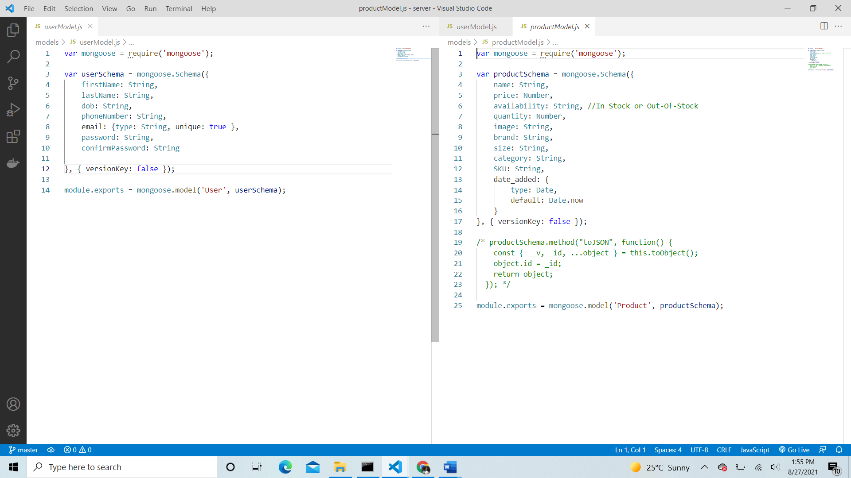

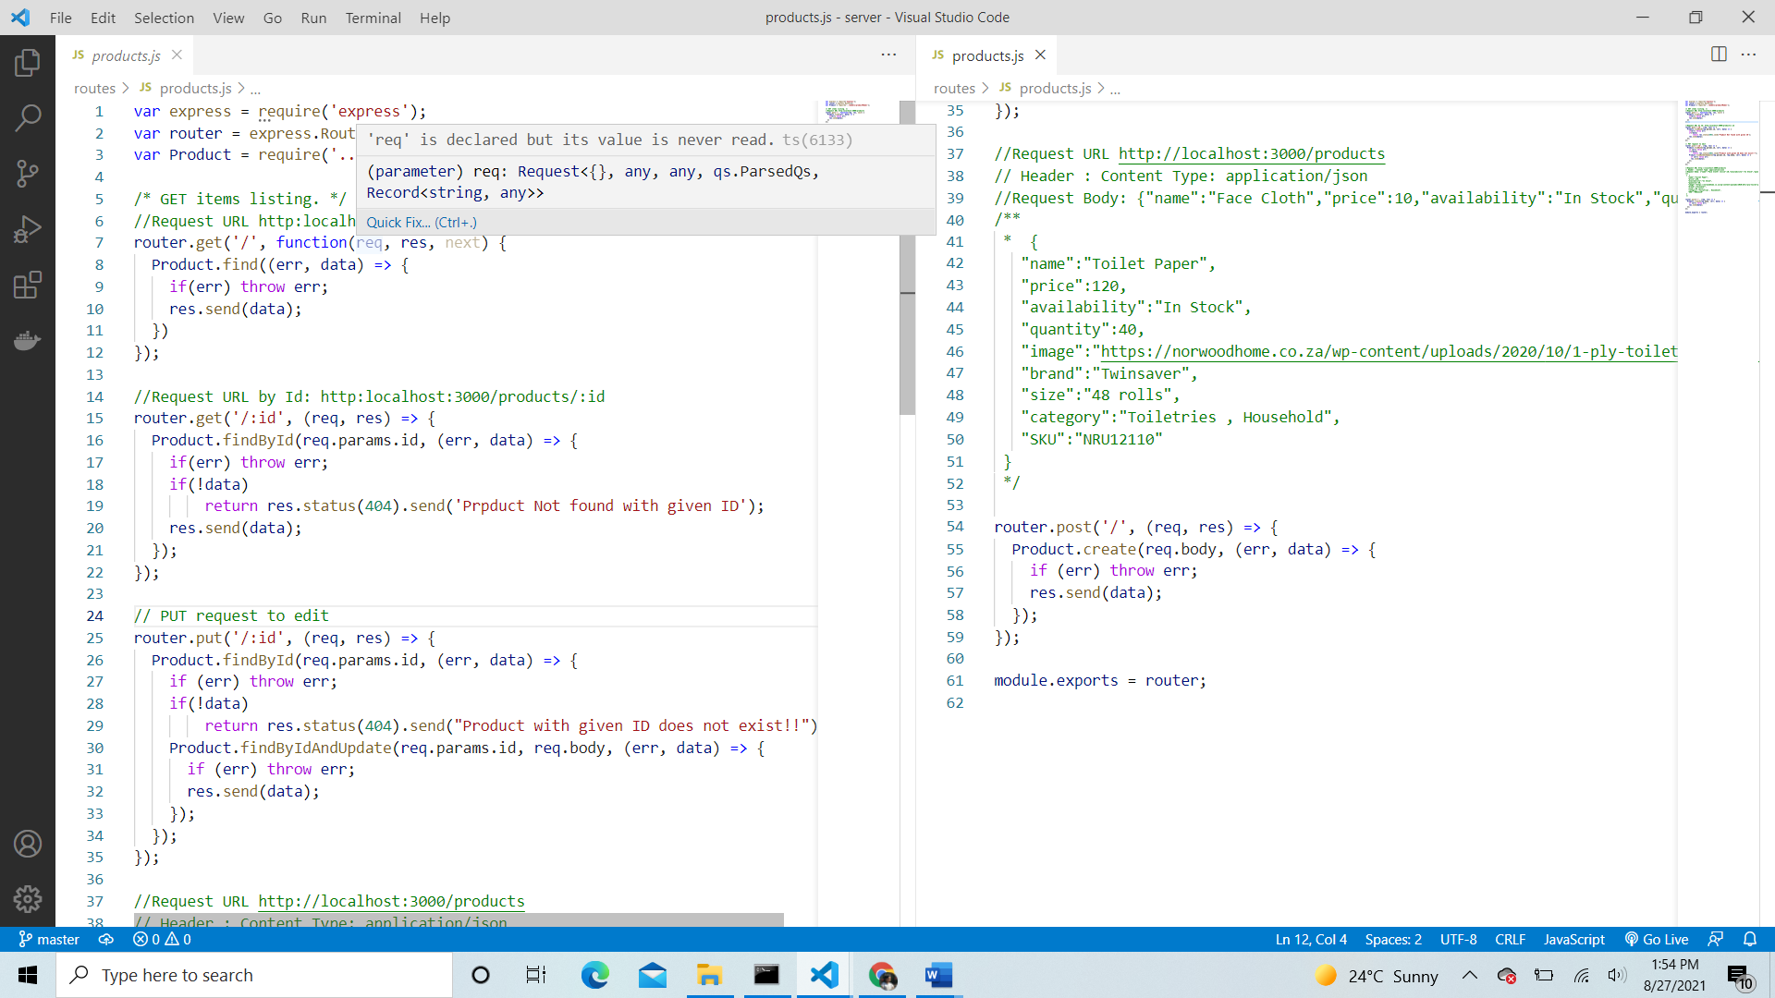



* app.js containing middleware

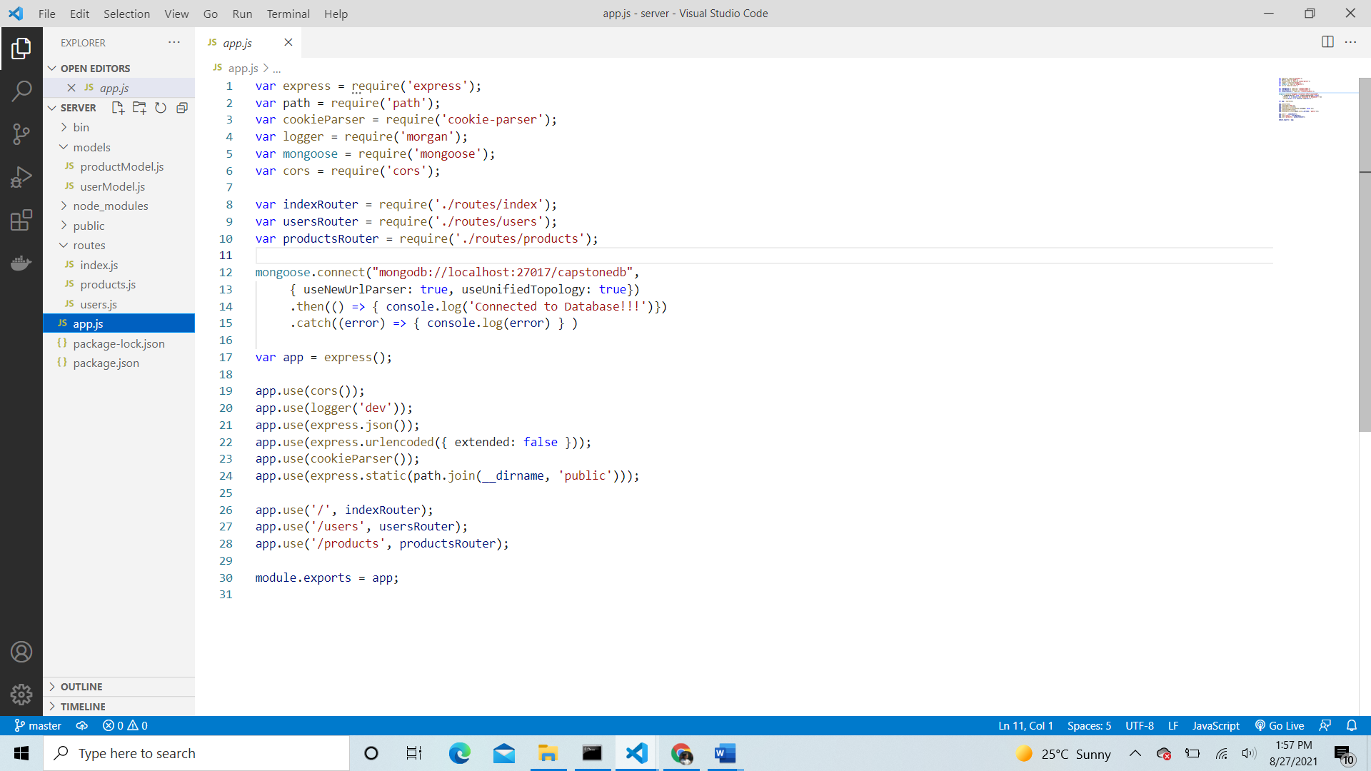

* API Requests – Used Postman and RestEasy to ensure API calls are working.

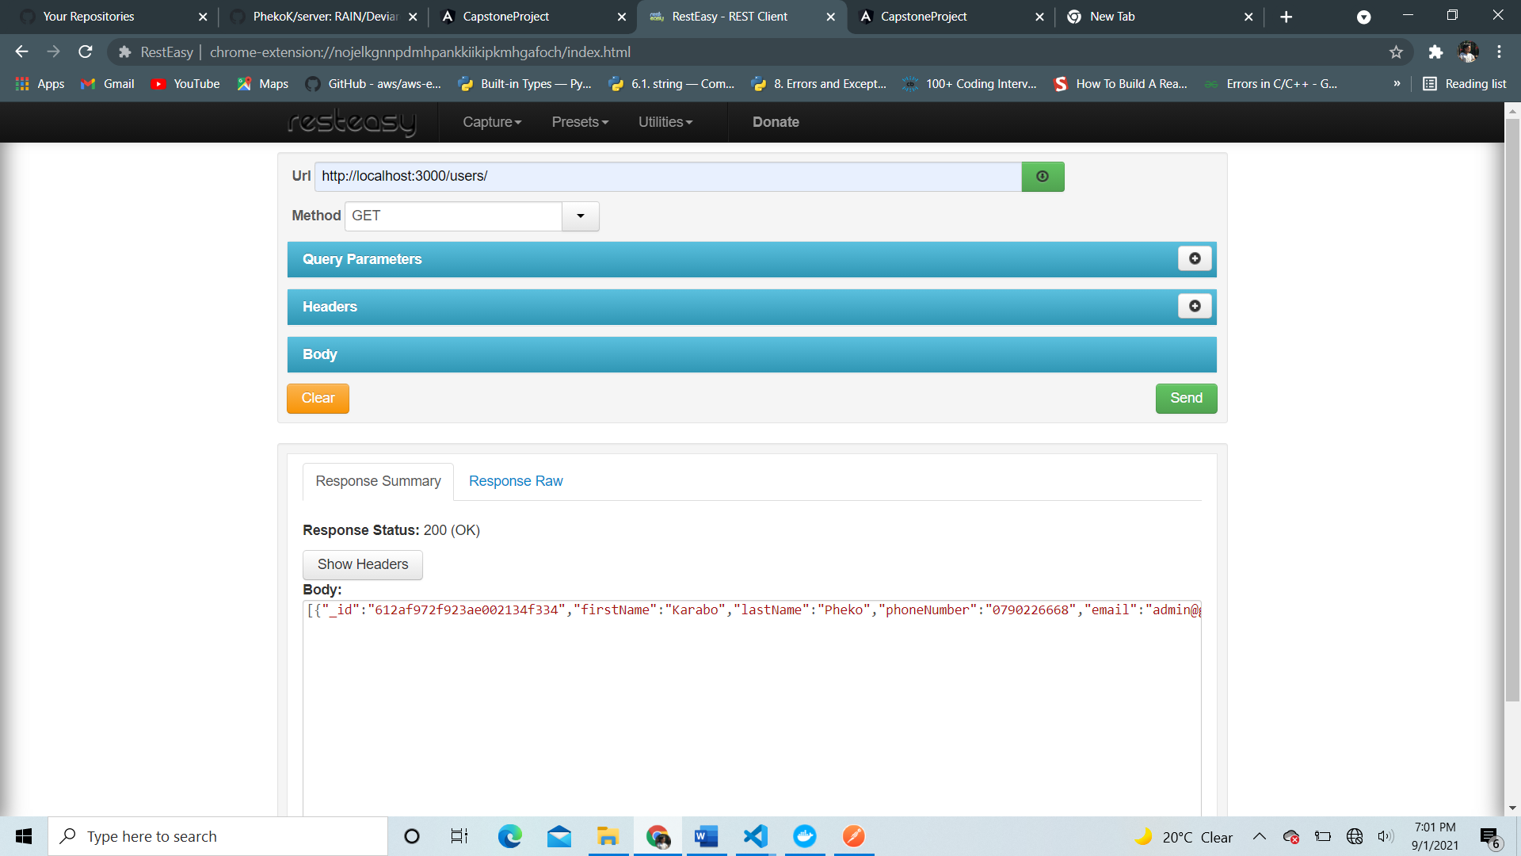

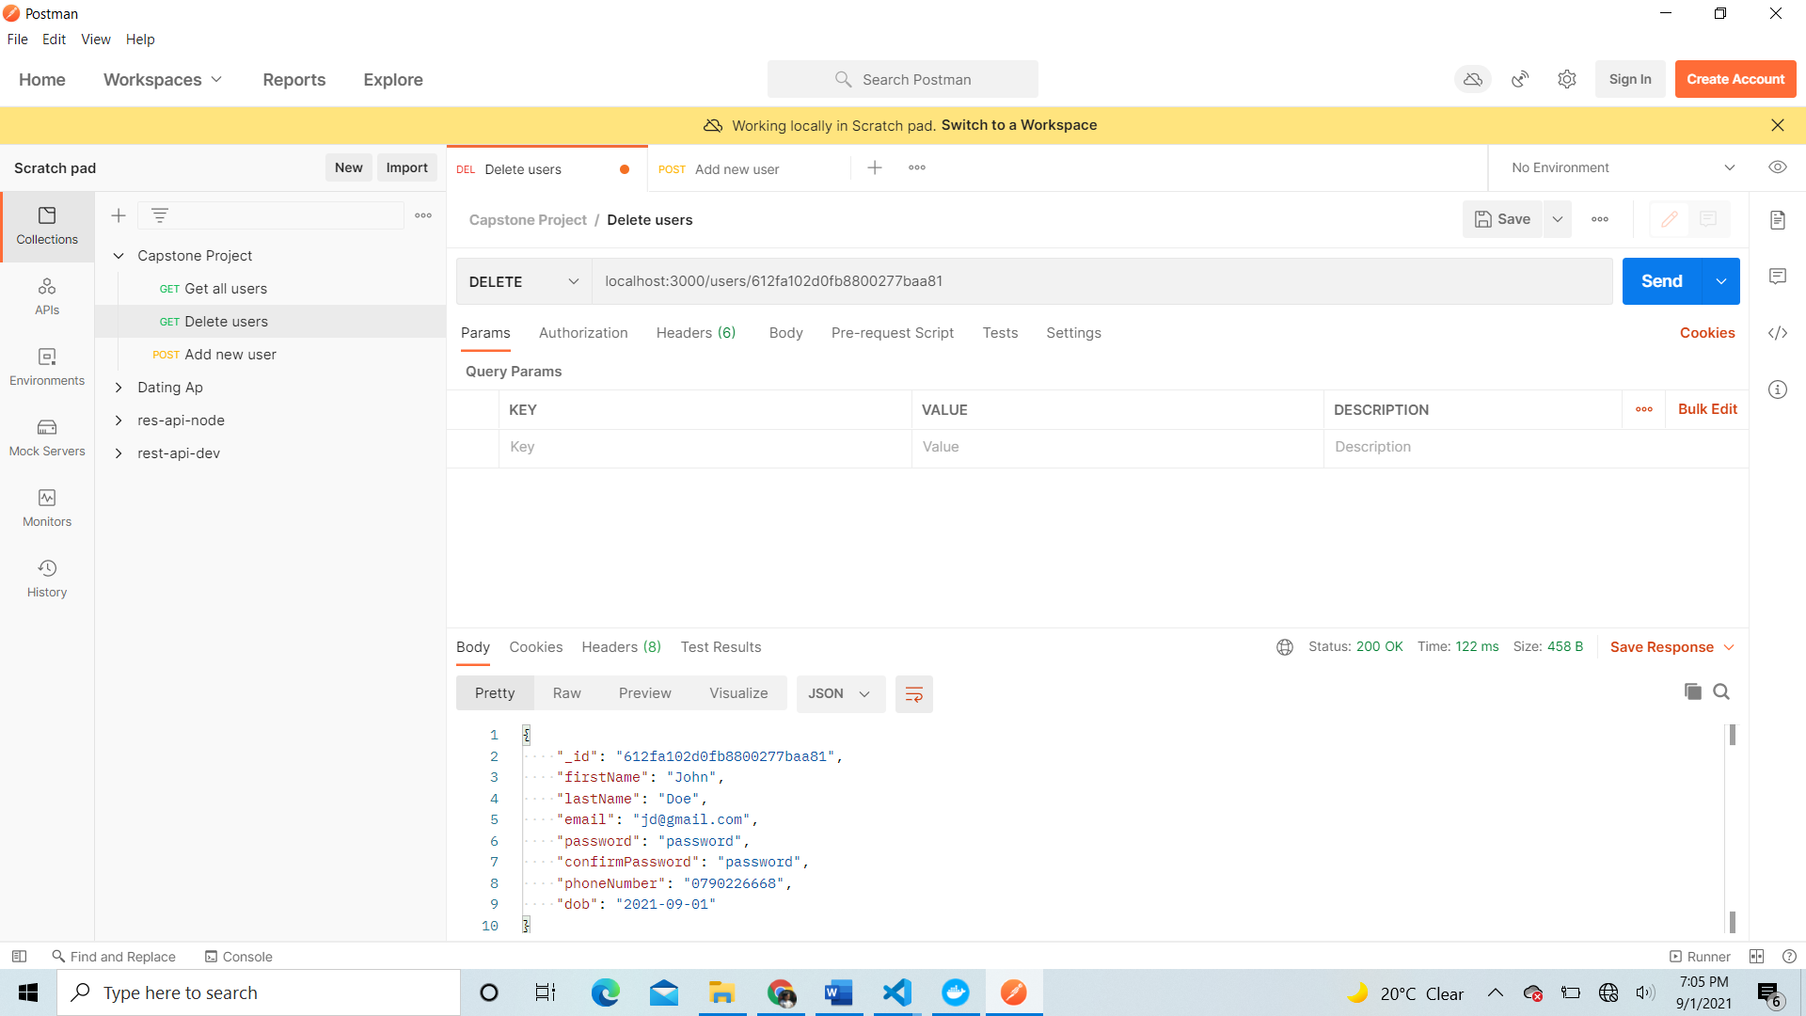

* Frontend – angular application
* User Portal
* Product viewing/catalogue page

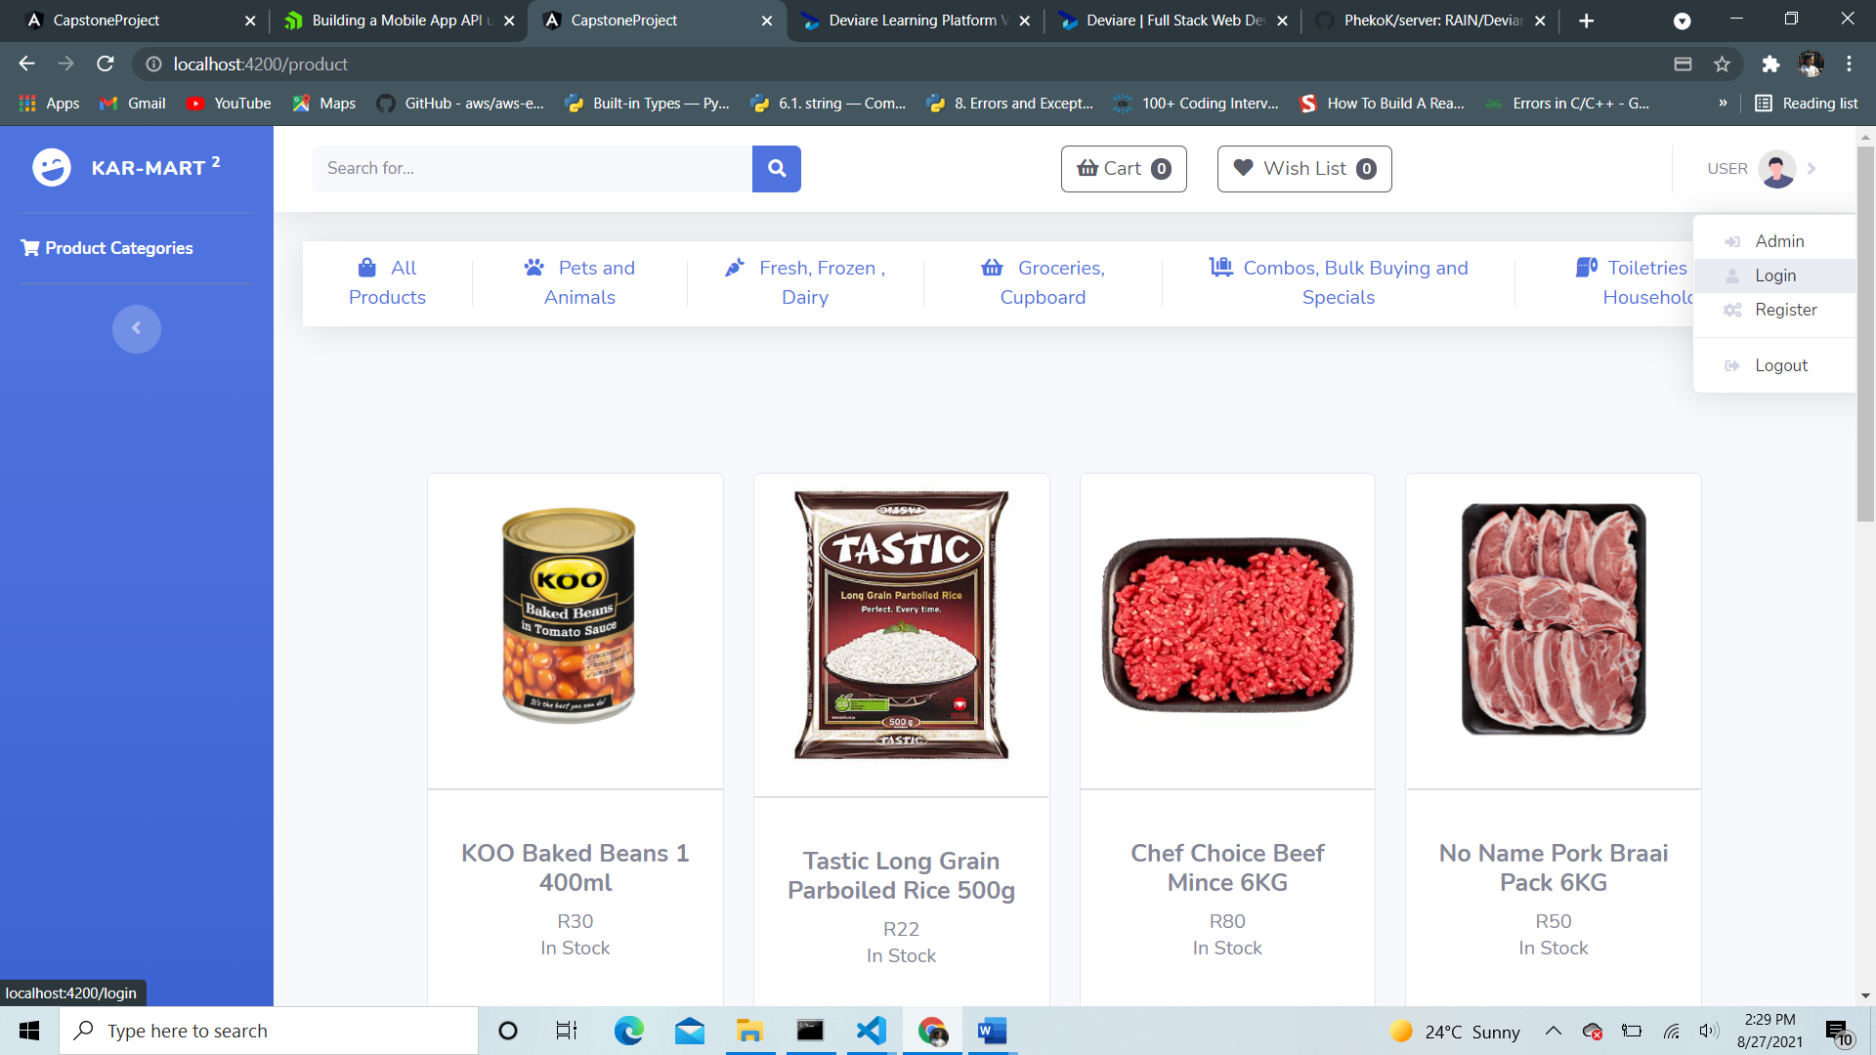

* Login page

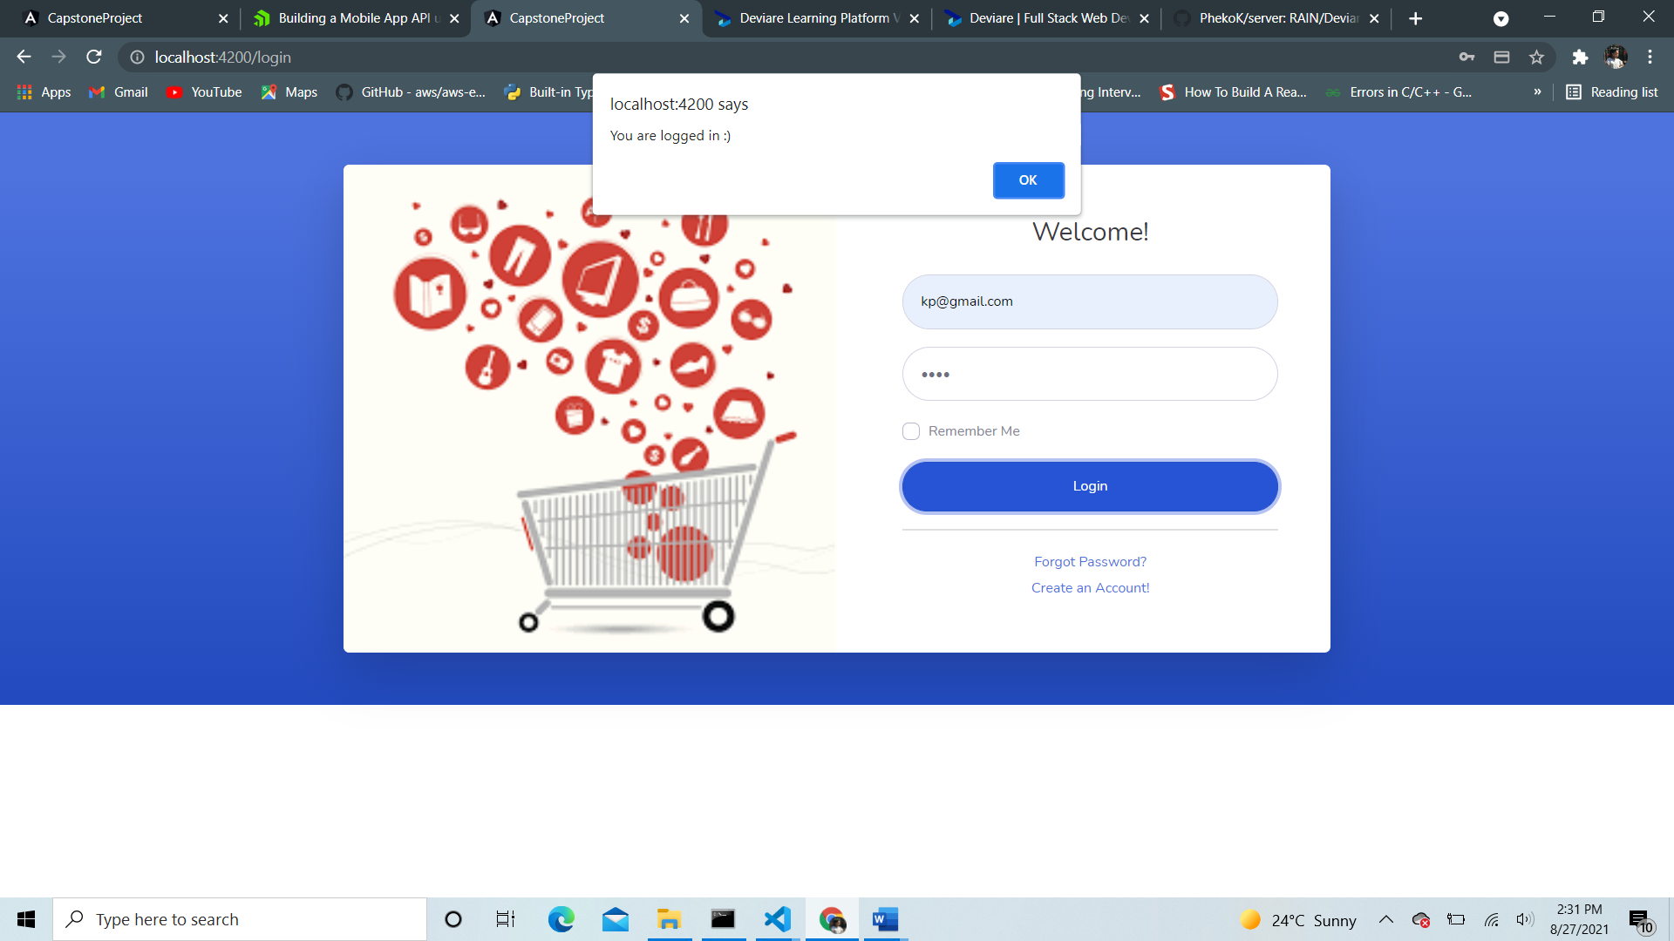

* Register page

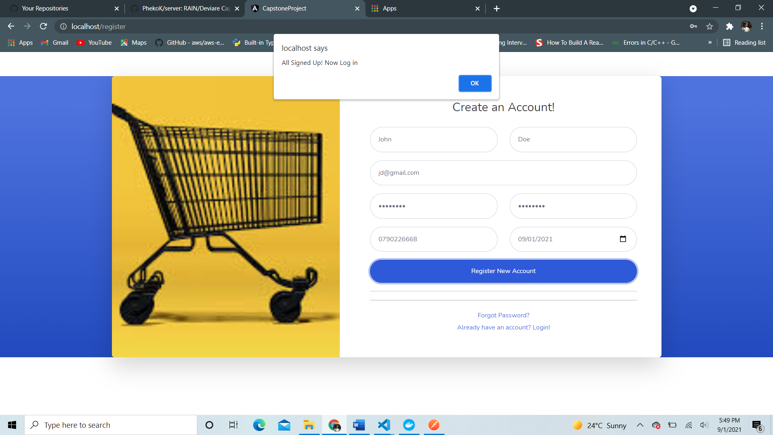

* Shopping cart (if cart is not empty)

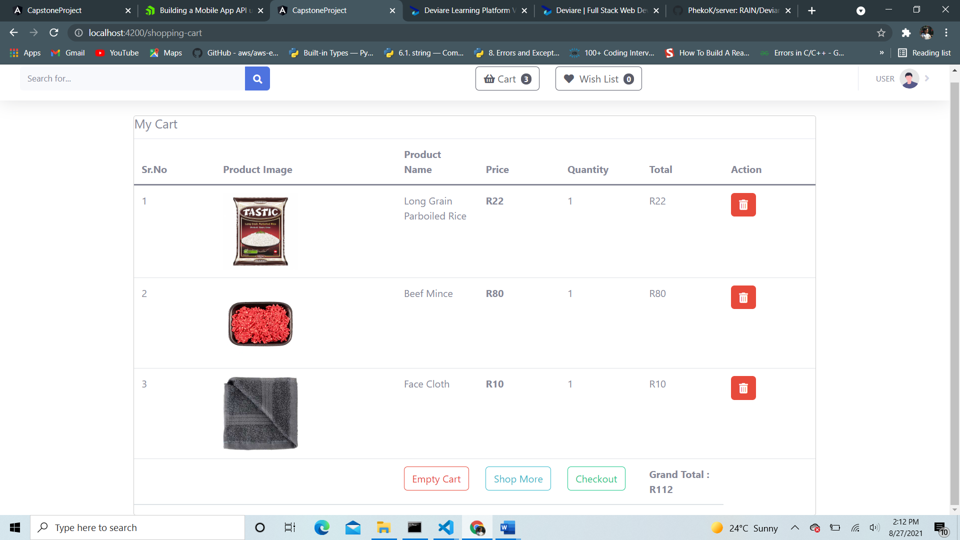

* Shopping cart (if cart is empty)

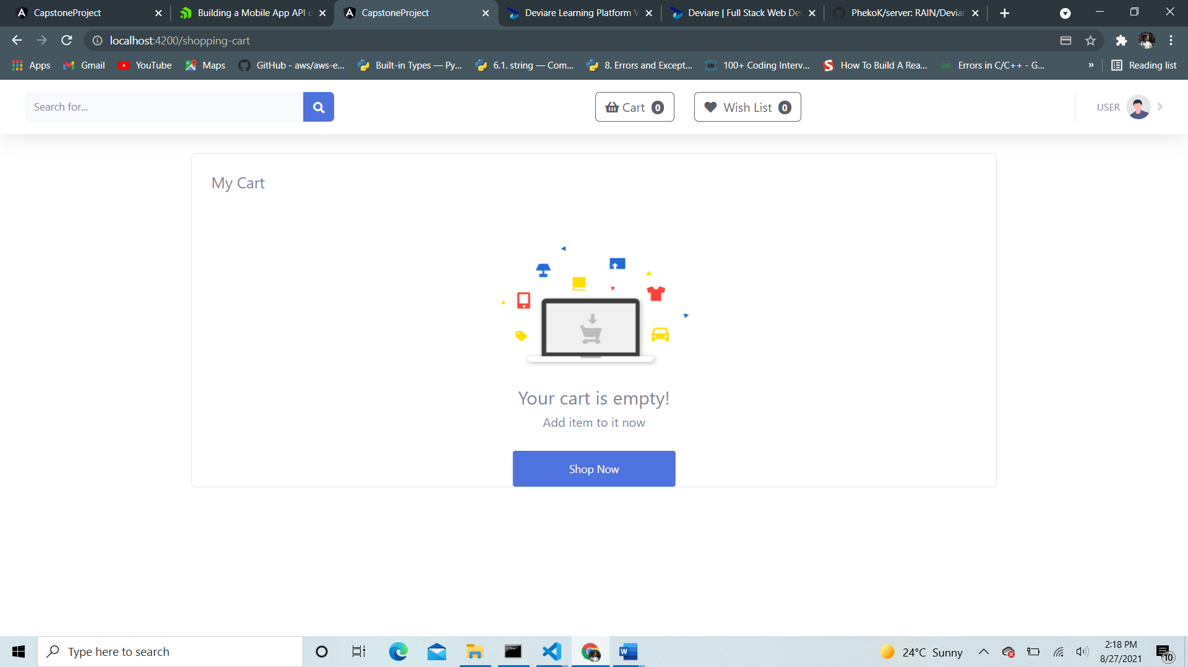

* Checkout page (takes billing information of user)

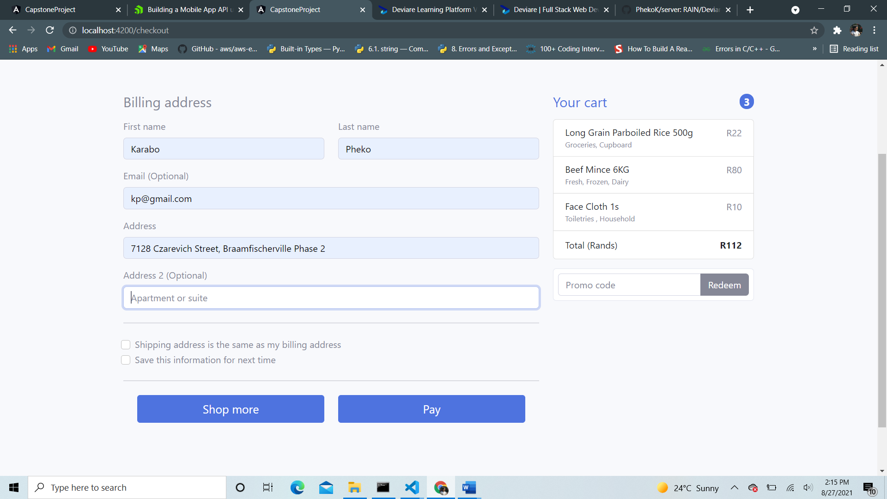

* Invoice page

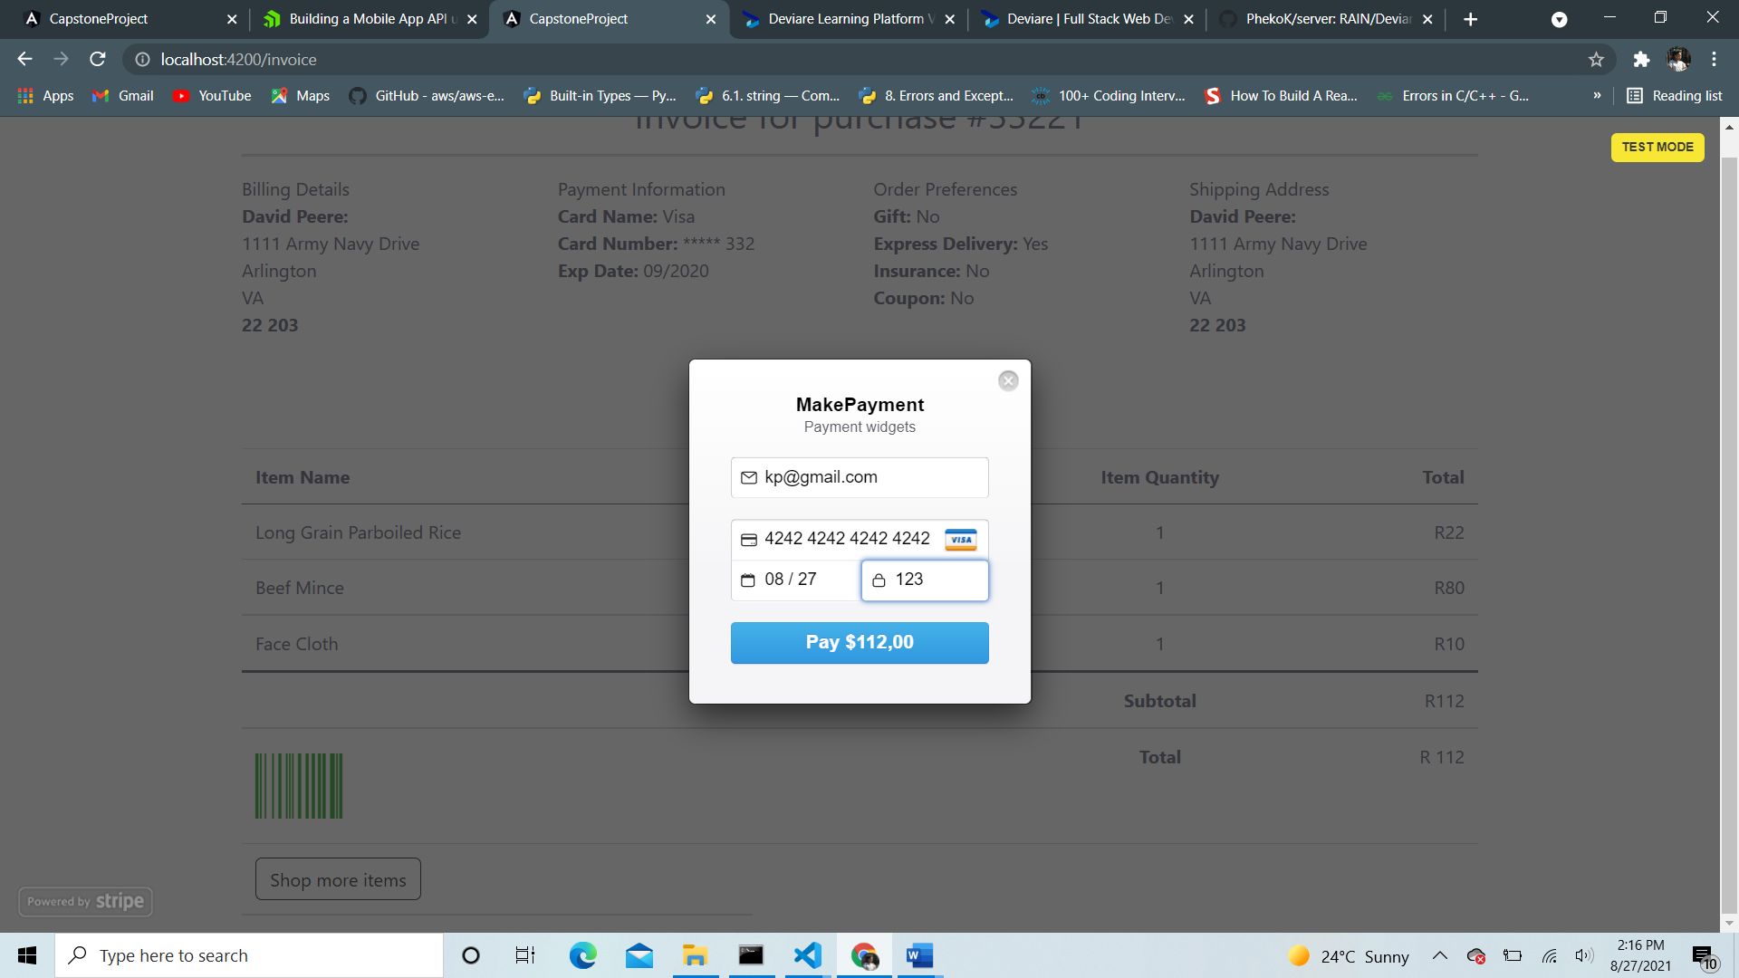

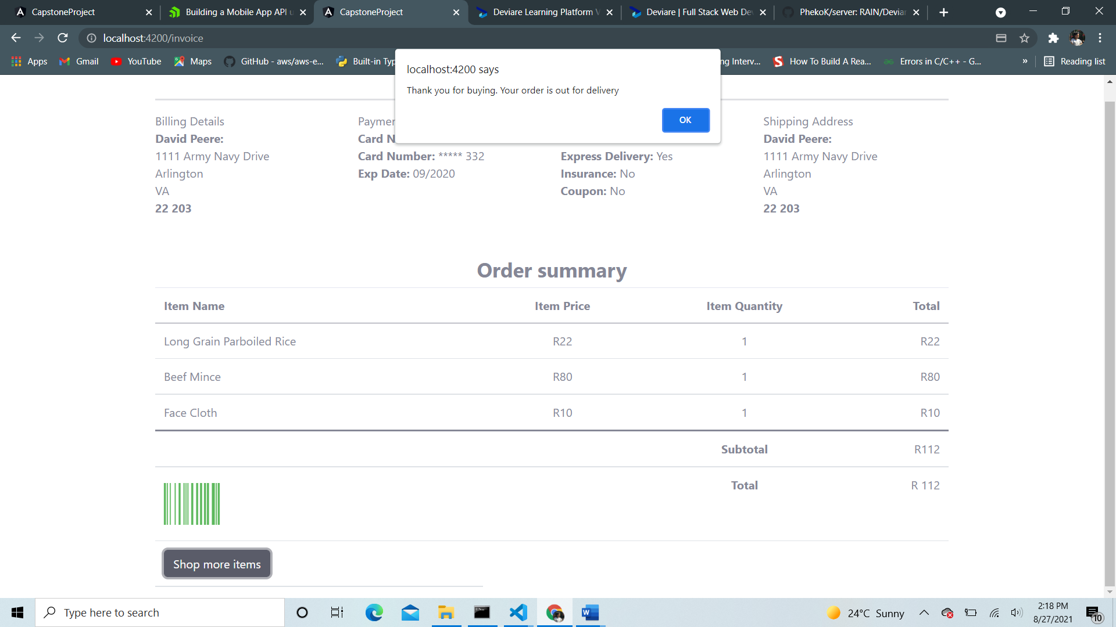

* Admin portal
* Admin dashboard – product overview and manage users

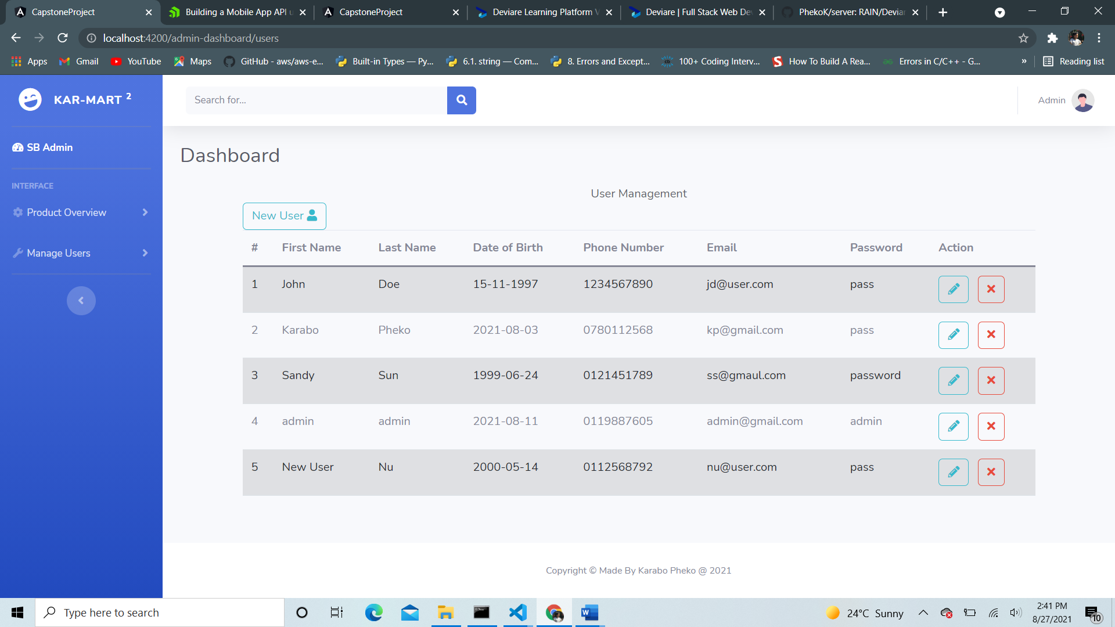

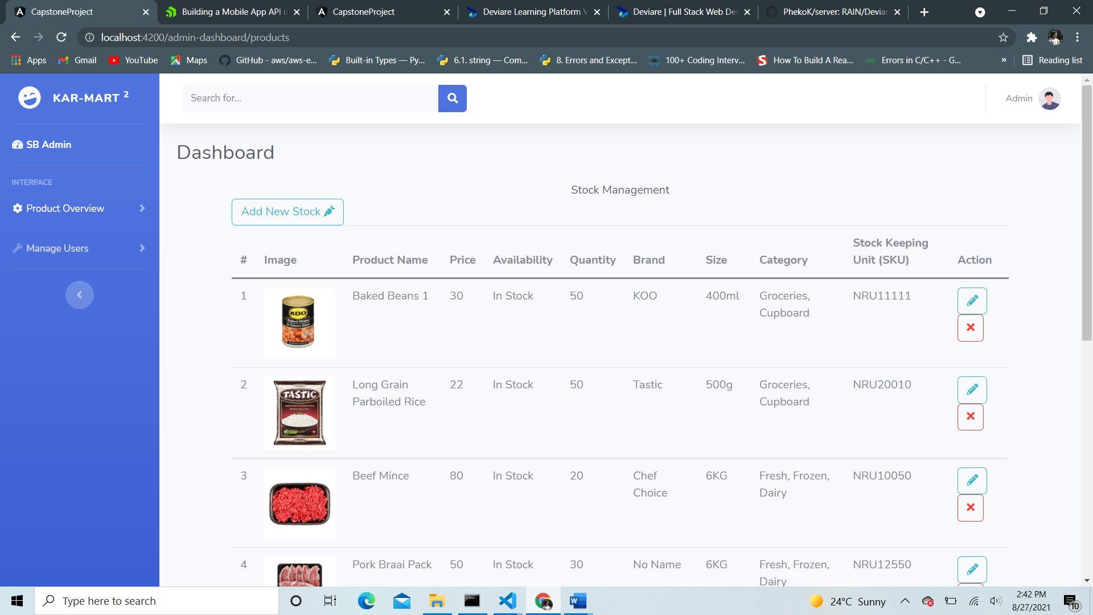

* Product add page – admin can add a new product in product catalogue

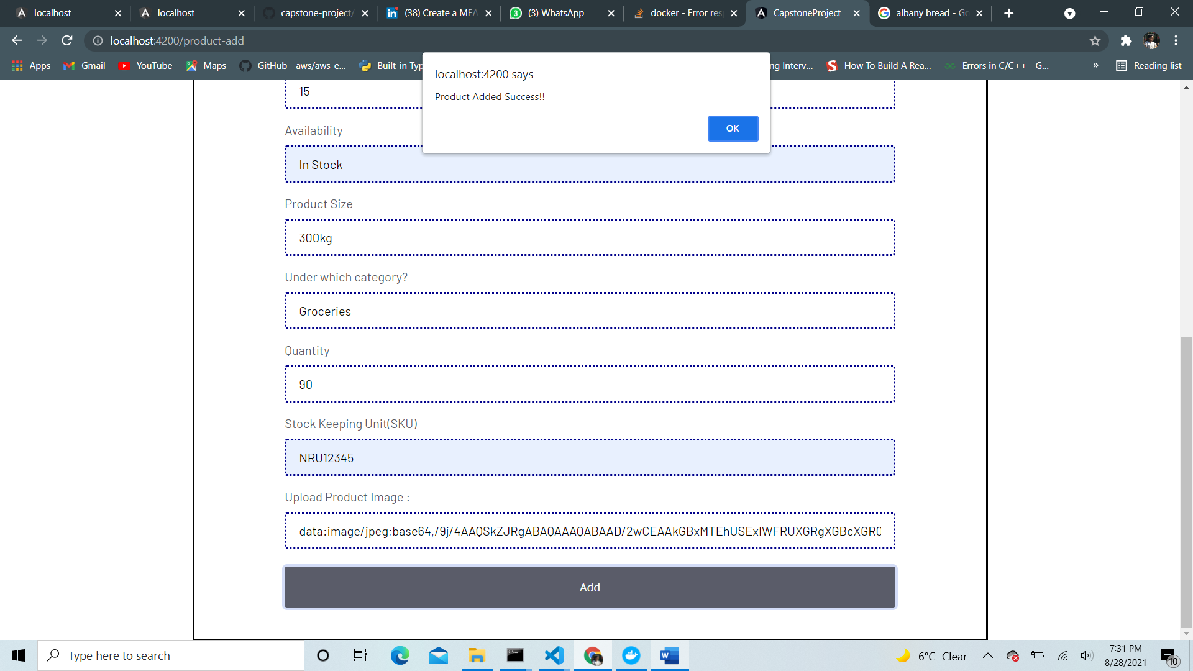

* Delete existing items from product

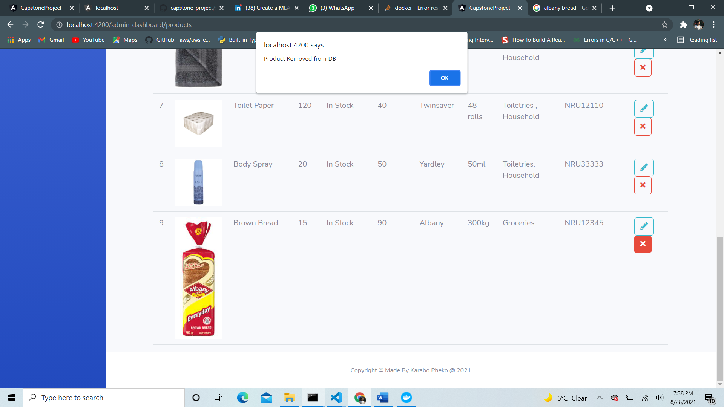

* Update existing products

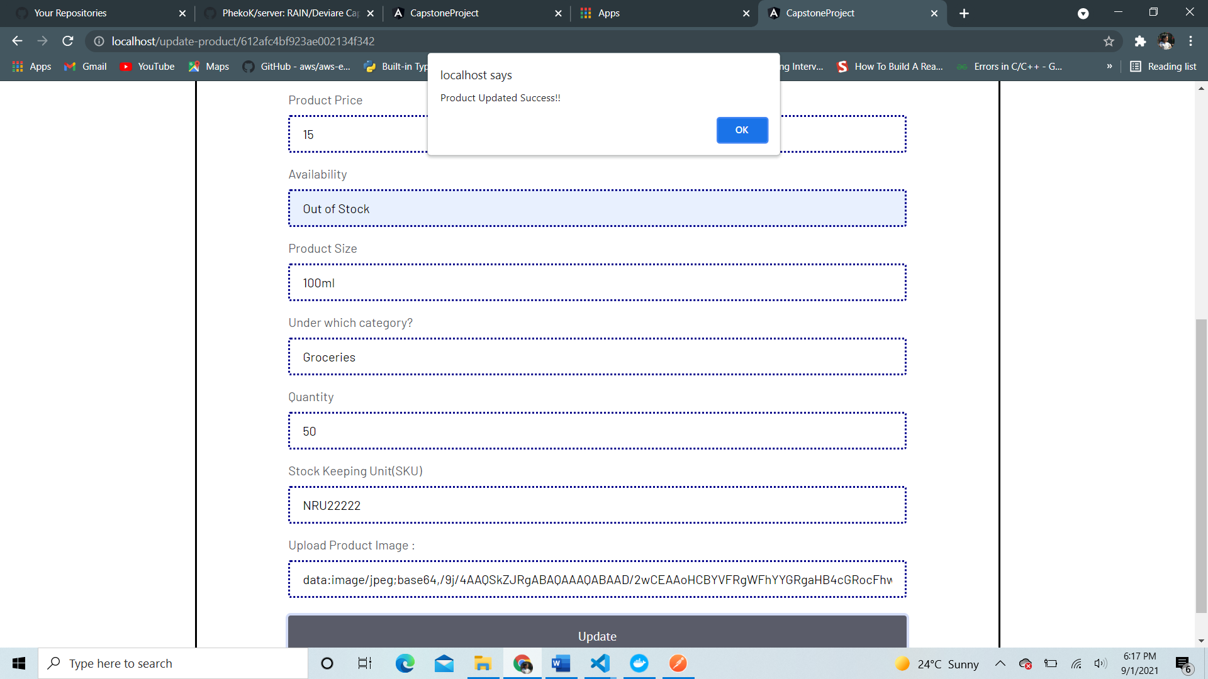

1. Production

* Containerize application using Docker
* Host to AWS EC2 instance

1. **AMAZON WEB SERVICES**
2. **Setting up EC2.**

* Since application is containerized, we set an EC2 instance for the container to run on.
* Navigated to AWS and logged in with my credentials.

1. Clicked ‘Services’ on the dropdown menu and selected ‘EC2’. Clicked ‘Launch Instance’ button

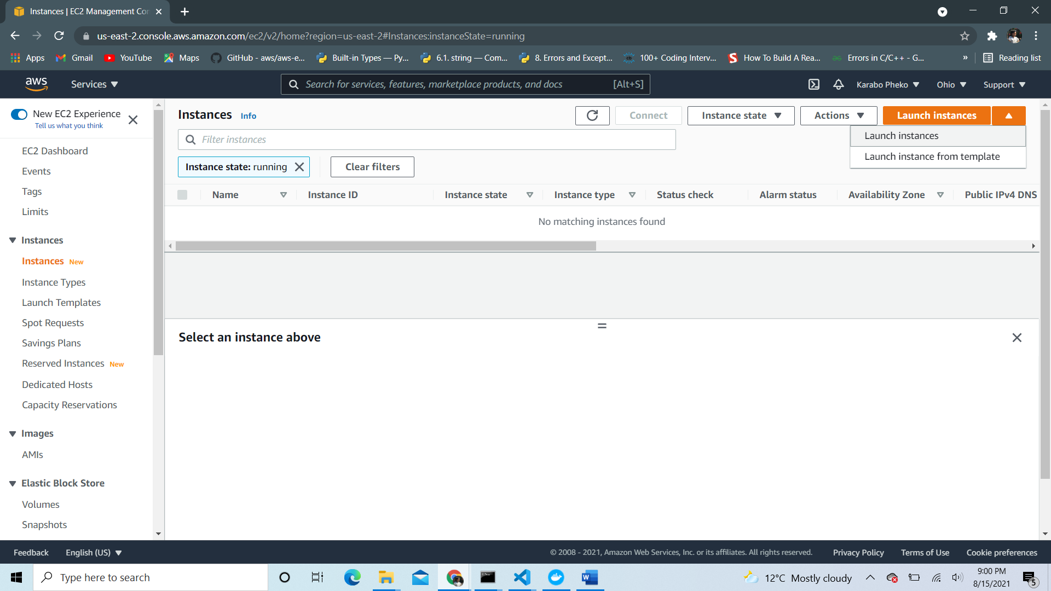

1. Step 1: Choose AMI – Ubuntu Server 18.04 in my case

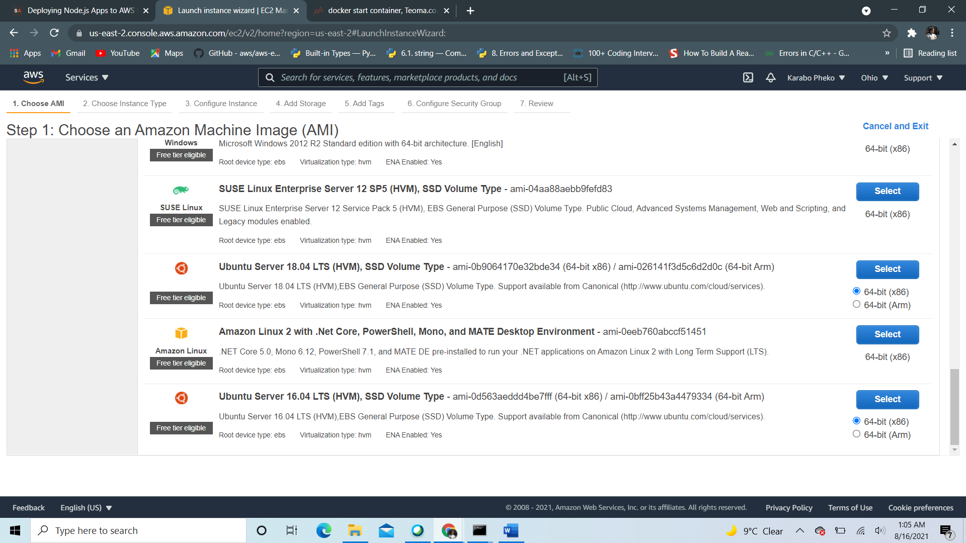

1. Step 2: Choose Instance type – t2-micro free tier.

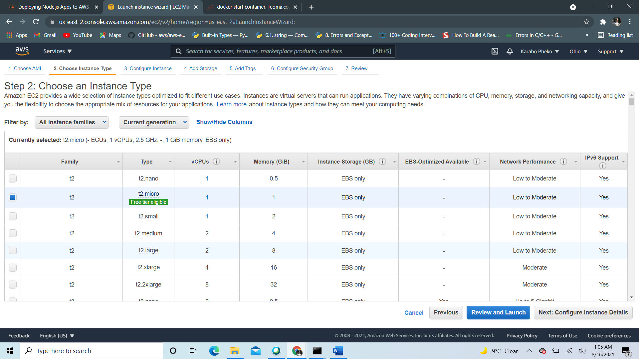

1. Step 5: Added (optional) tags

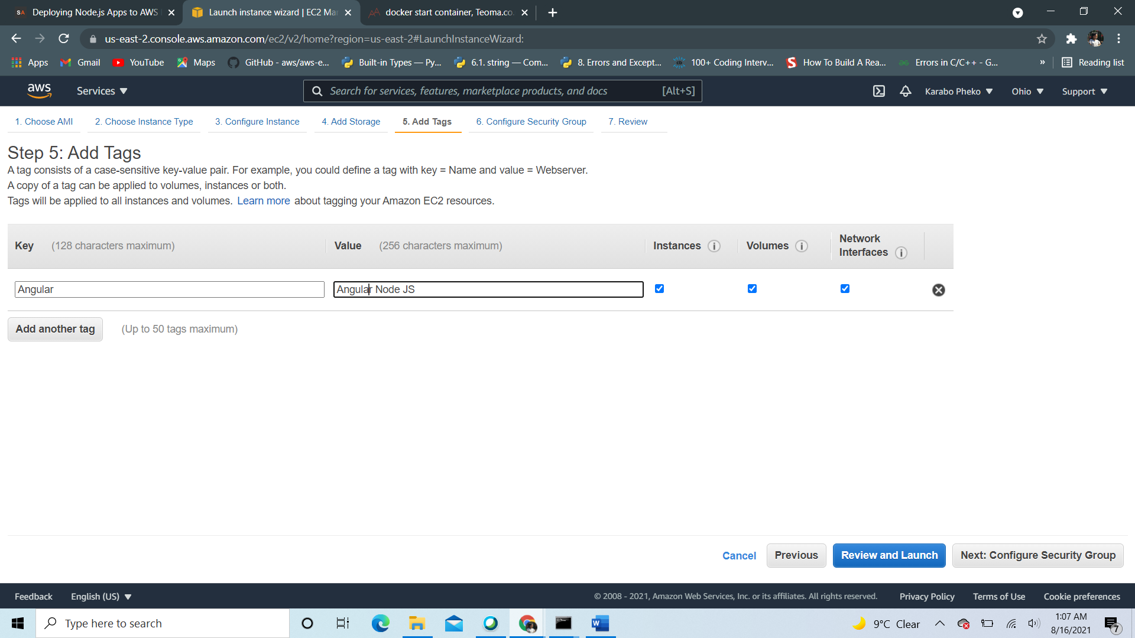

1. Step 6: Configured Security Group – added http rule

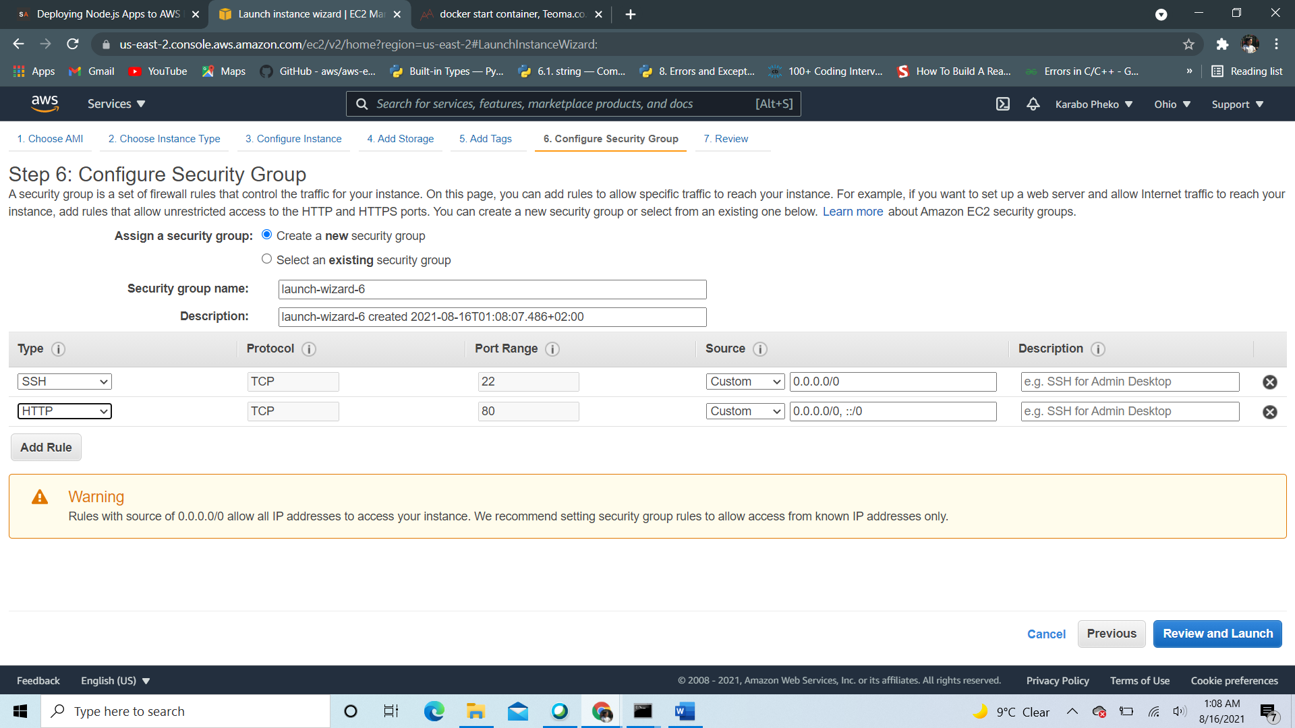

1. Step 7: Reviewed and Launched – Downloaded a .ppk file

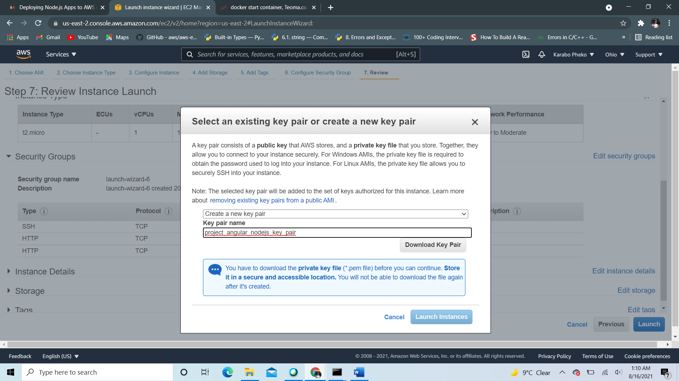

* Launched Instance – Instance is running

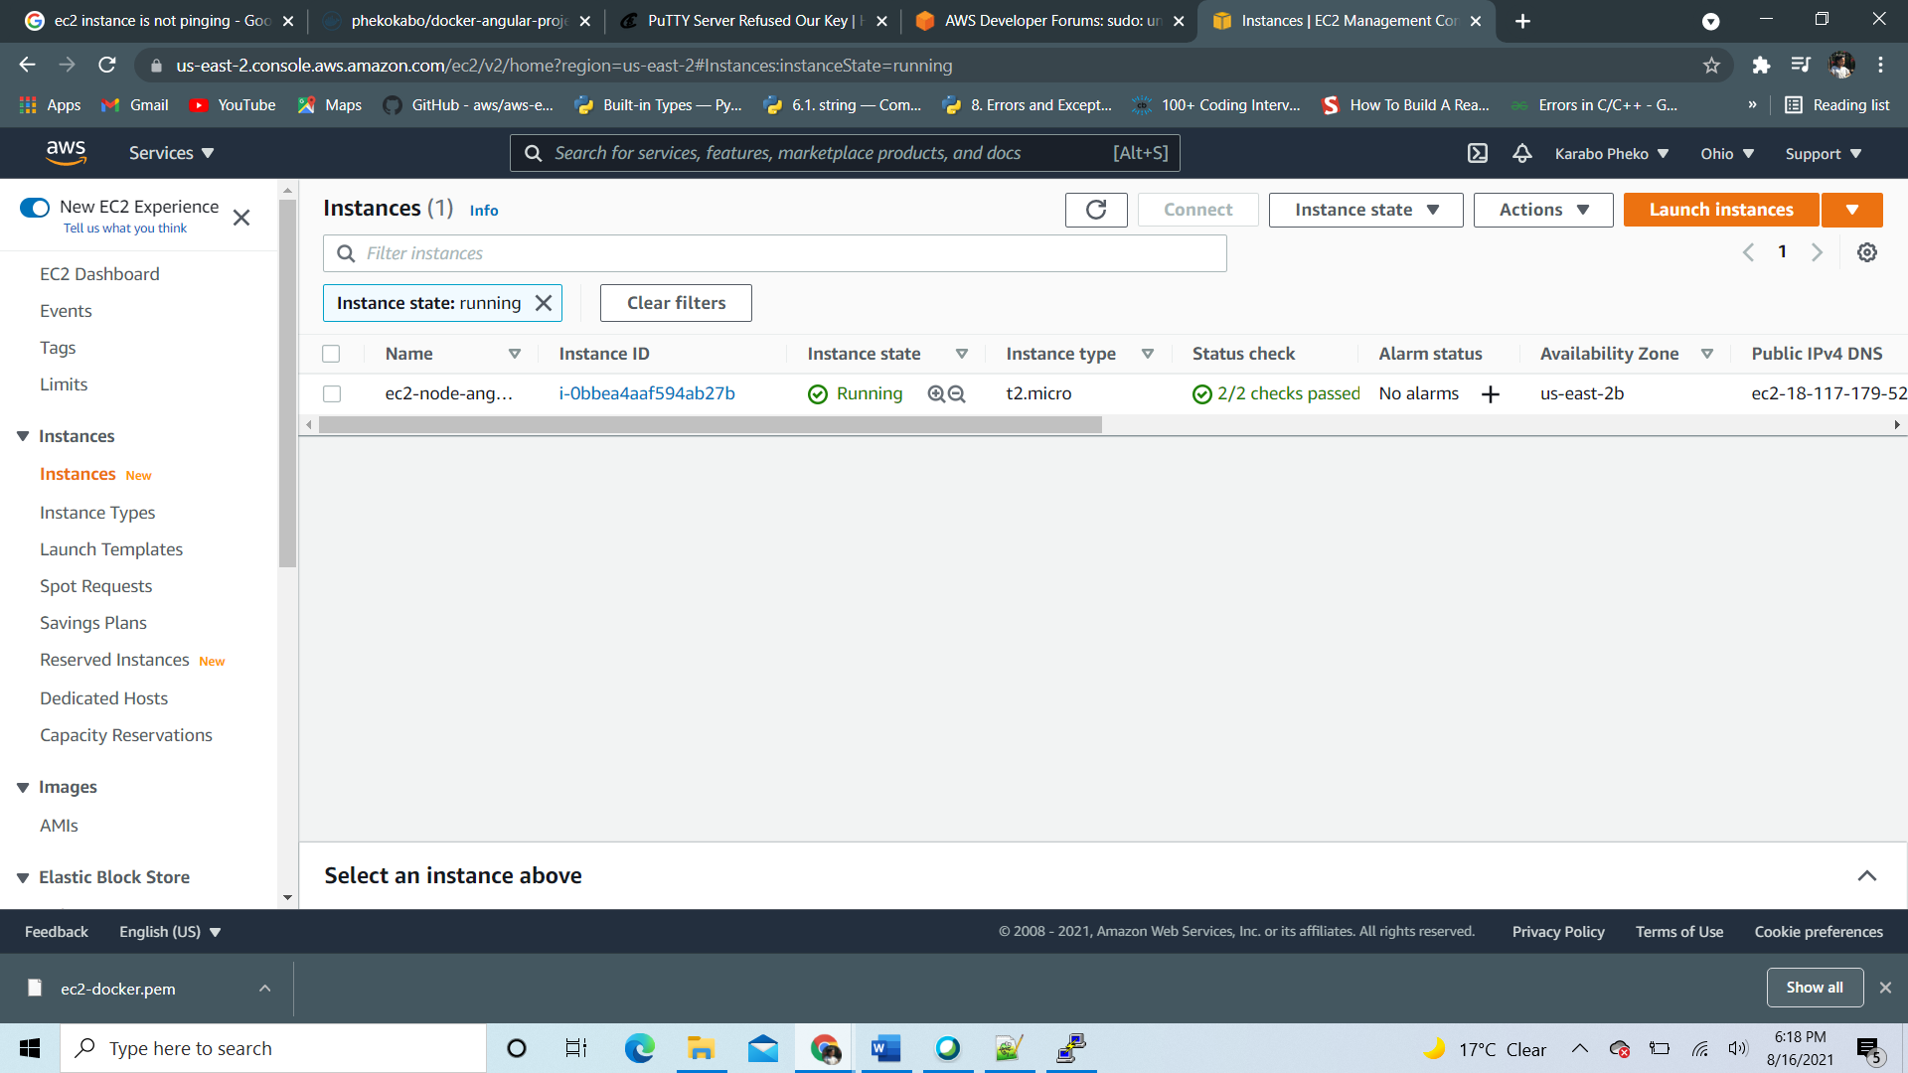

1. Launch EC2 instance using putty or virtual machine provided by AWS and SSH into the Amazon virtual machine by using the public IPv4 DNS detailed after I launched the instance.

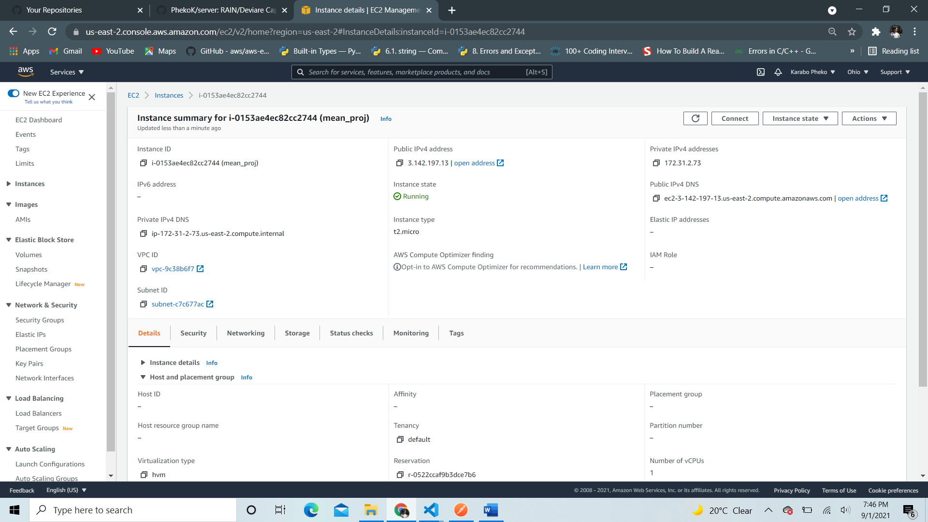

* Then the following instance is launched.

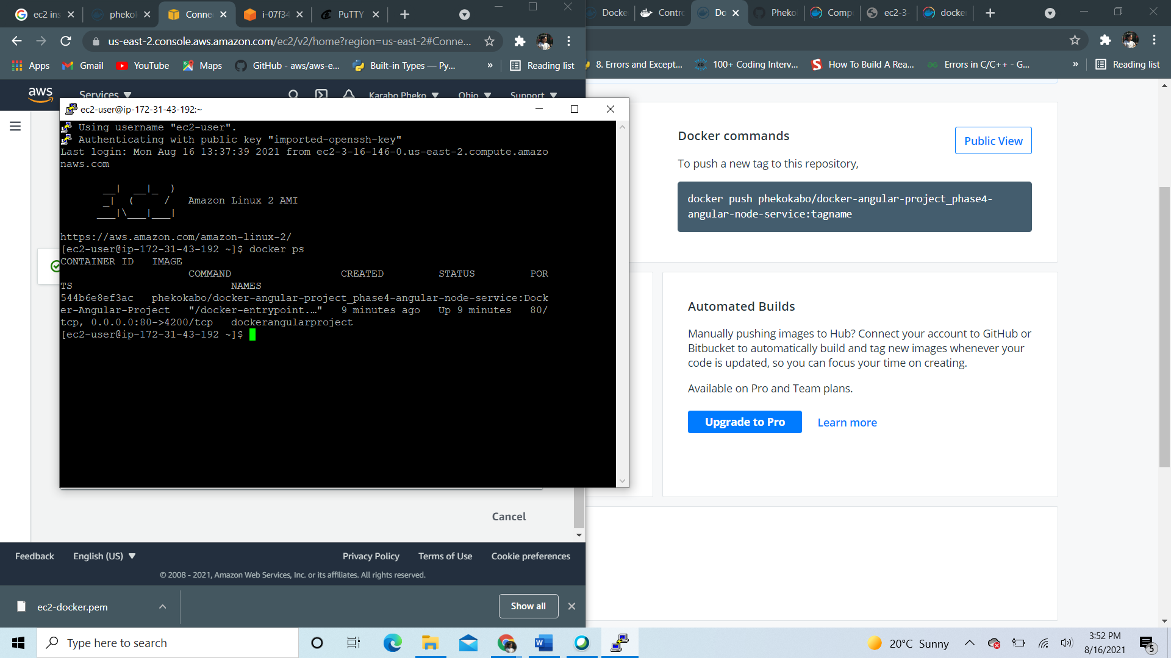

* Alternatively you could use the one provided by putty by the following steps…

1. Open puTTygen and generate a private key, click load and add key with a .pem extension (Privacy Enhanced Mail) – used to sign me in in my SSH terminal to the virtual machine
2. Once selected, click ‘Save private key’ and your key is generated.
3. Once saved, use the key to connect to putty and open the virtual machine provided putty, by providing the IPv4 address as your address, the login username, i.e ubuntu, and the private key file generated by puTTygen for authentication with the .ppk extension and your instance is launched!

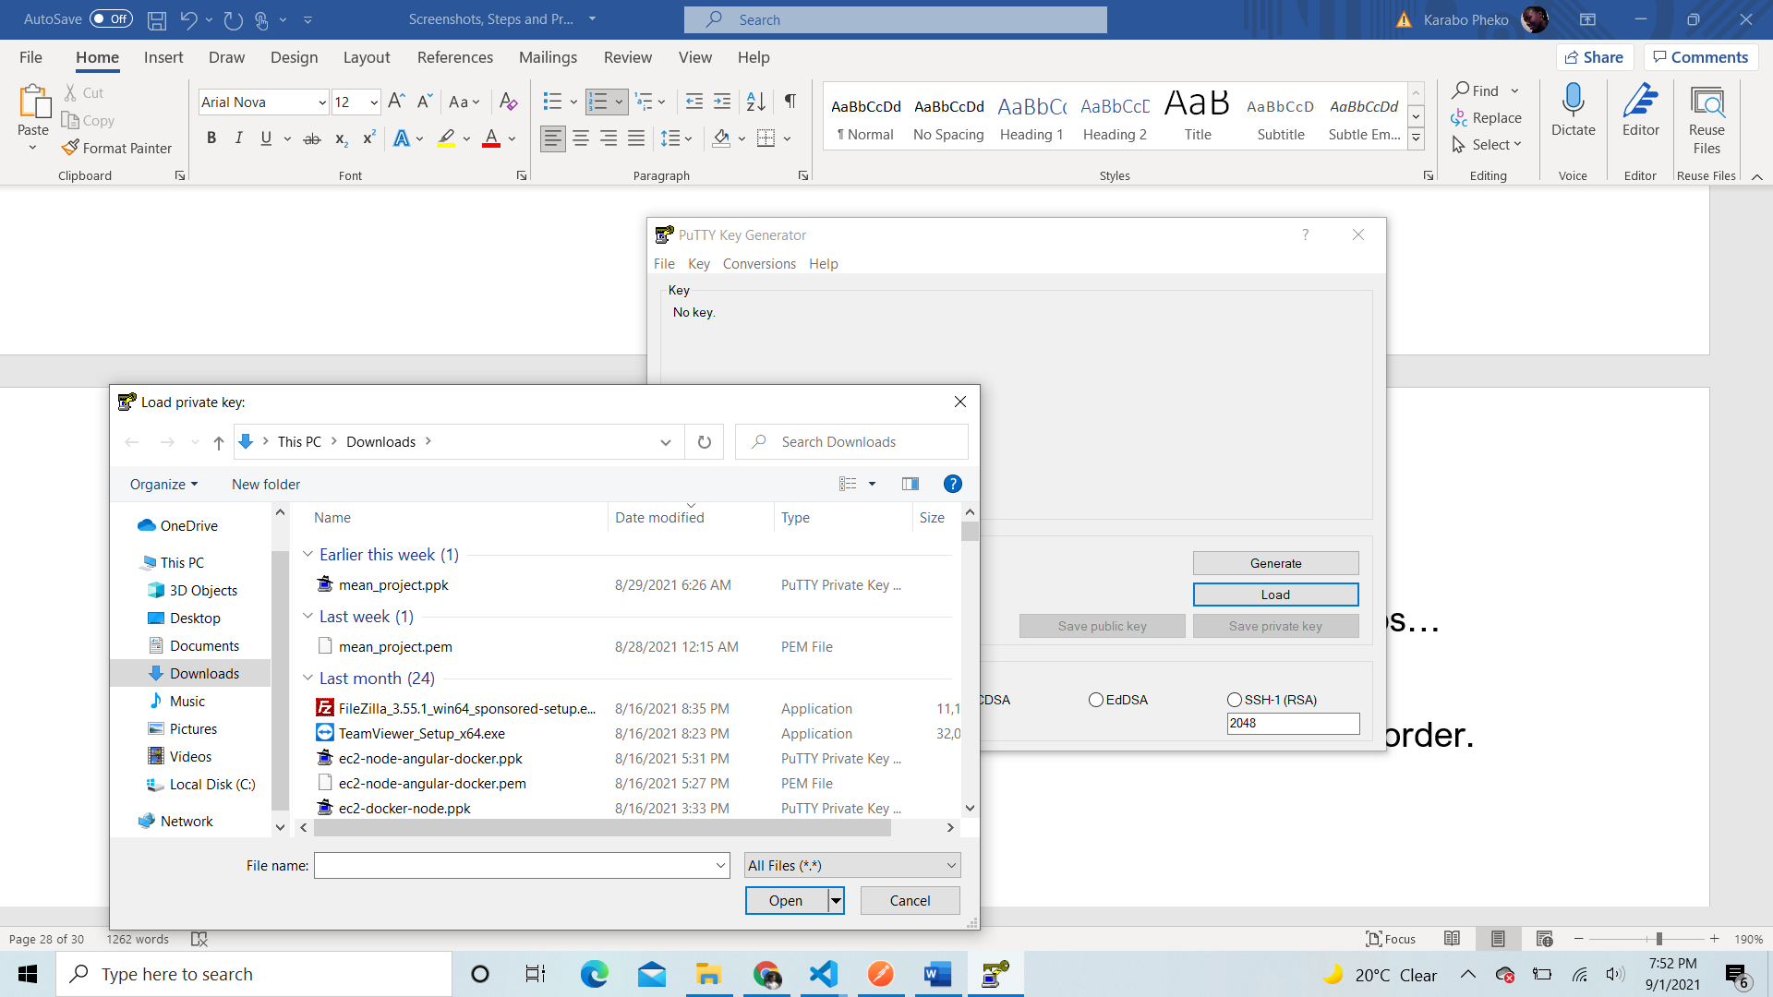

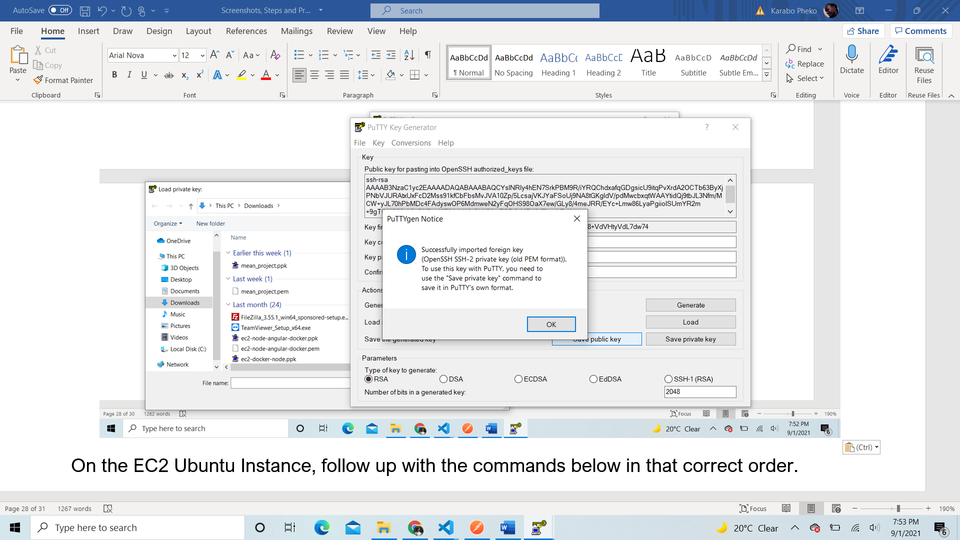

1. Once generated, head to putty to launch your instance and should look like something like this

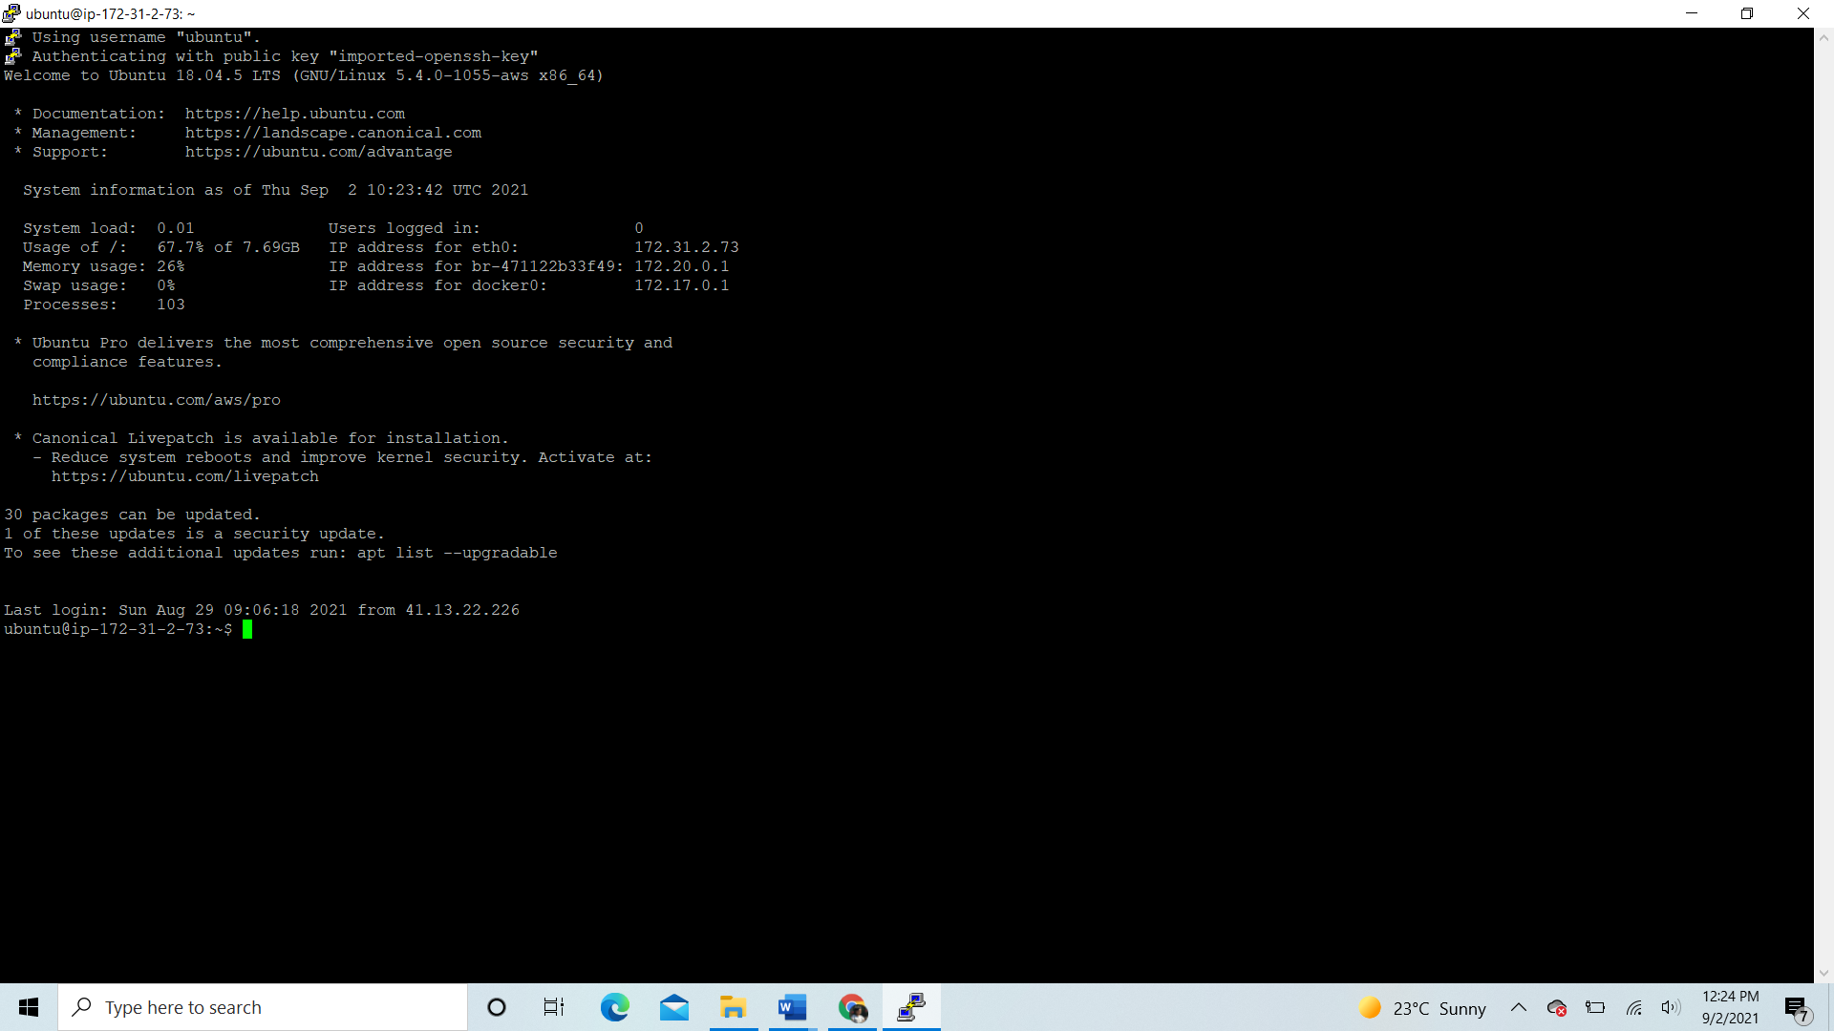

On the EC2 Ubuntu Instance, follow up with the commands below in that correct order.

1. sudo apt-get update
2. sudo apt-get upgrade
3. sudo apt-get install \

apt-transport-https \

ca-certificates \

curl \

gnupg-agent \

software-properties-common

1. curl -fsSL https://download.docker.com/linux/ubuntu/gpg | sudo apt-key add -
2. sudo apt-get install docker-ce docker-ce-cli containerd.io
3. apt-cache madison docker-ce
4. sudo apt-get install docker-ce docker-ce-cli containerd.io
5. sudo apt install docker.io
6. sudo apt install docker-compose

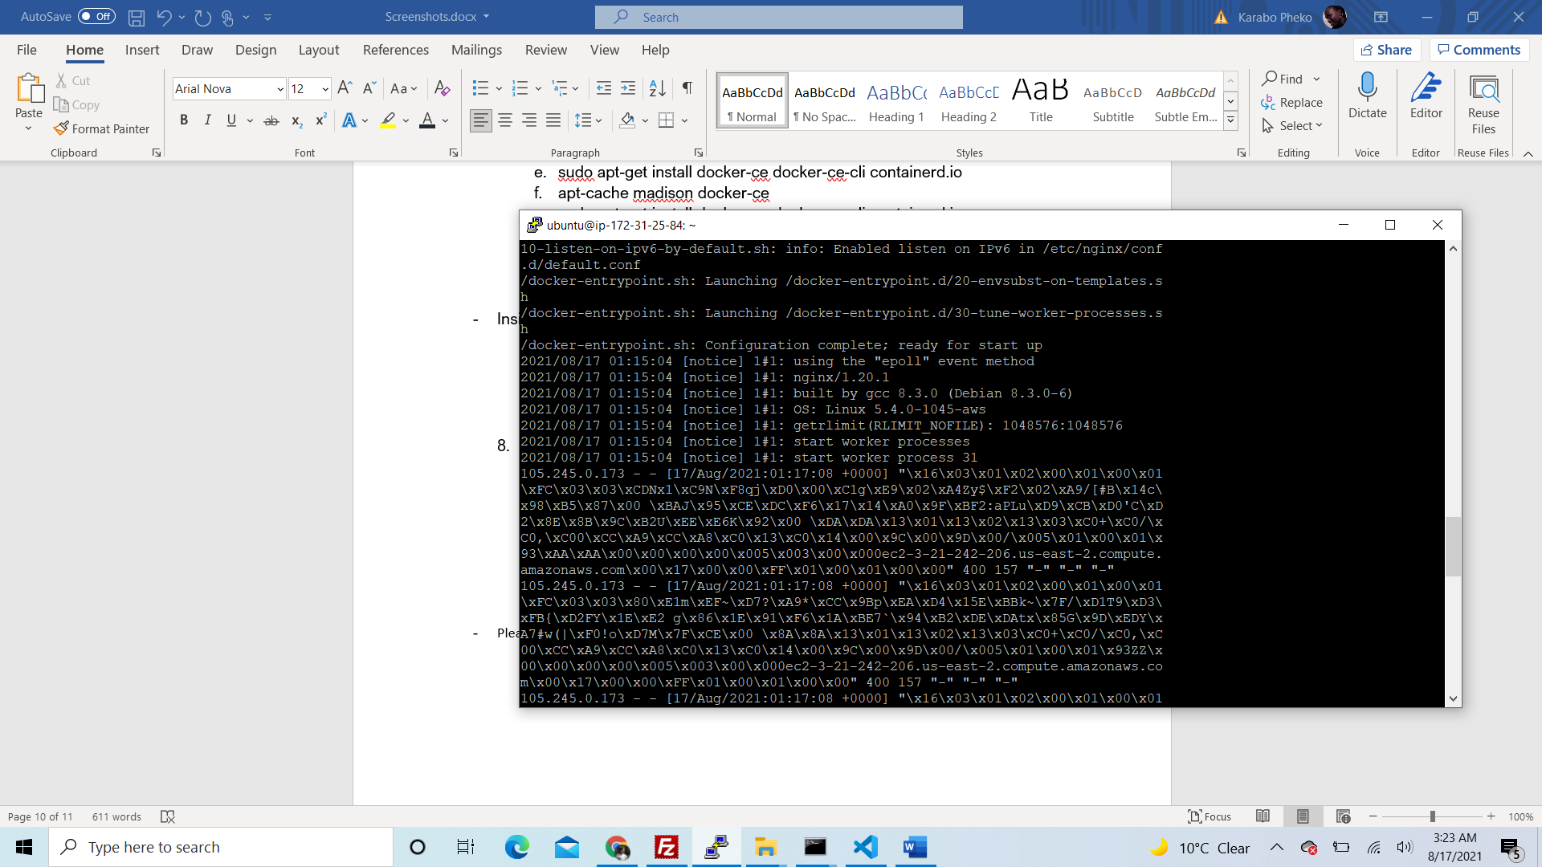

* git clone your backend and fronted application to your instance like so:

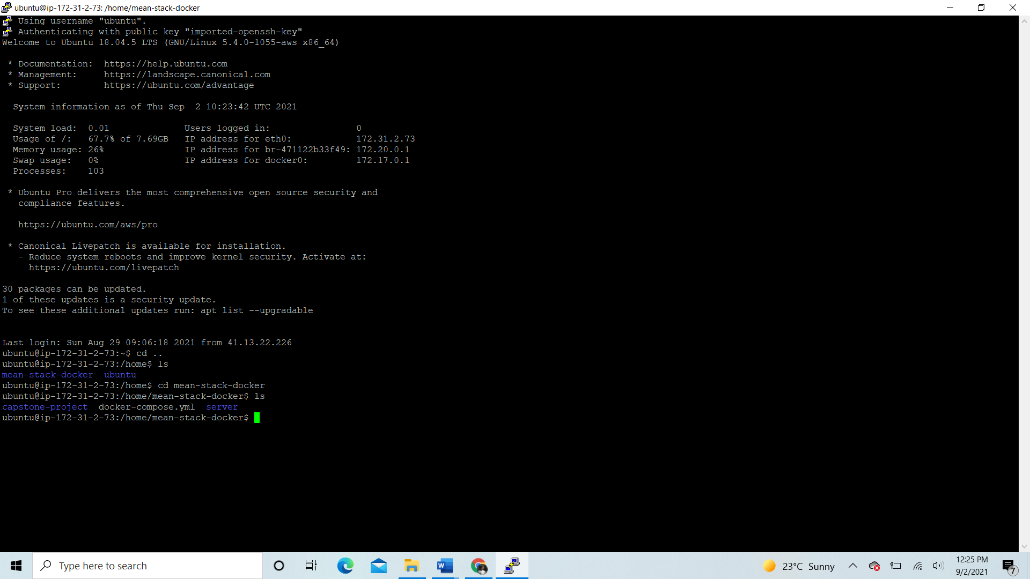

* cd to capstone-project (frontend) and install nginx server

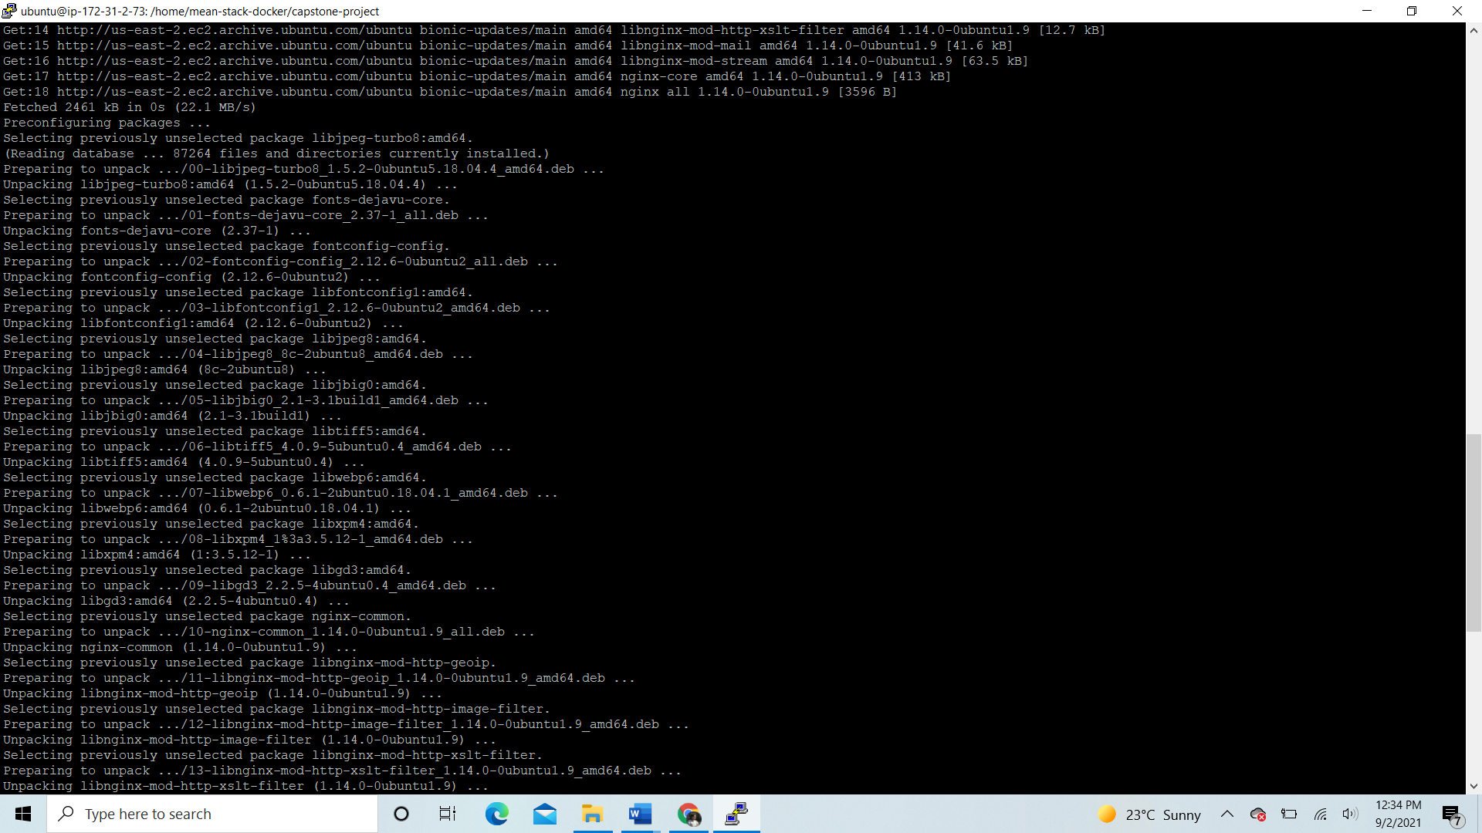

* Run ‘sudo apt-get install build-essential libssl-dev’ to install node

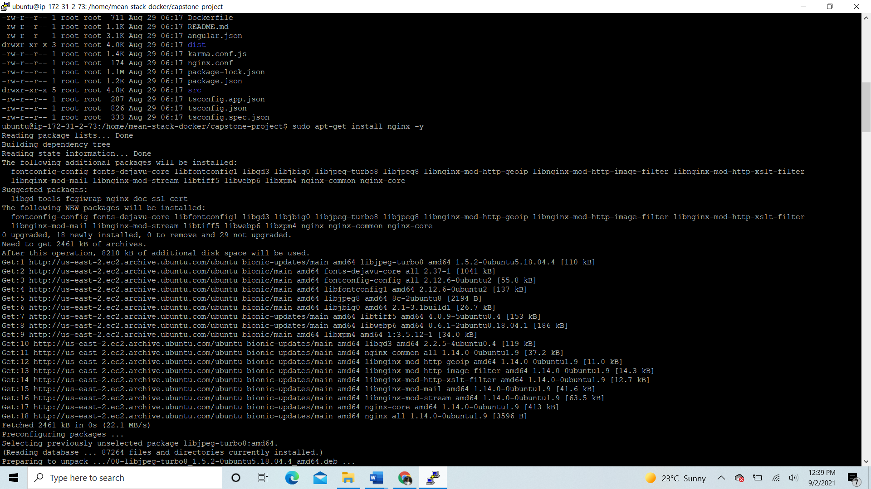

* Run ‘curl -o- <https://raw.githubusercontent.com/nvm-sh/v0.34.0/install.sh> | bash’ to install node version manager.
* Ran ‘. ~/.nvm/nvm.sh’ to activate nvm
* Ran ‘nvm install node’ to install node where we will use node version 16.8.0

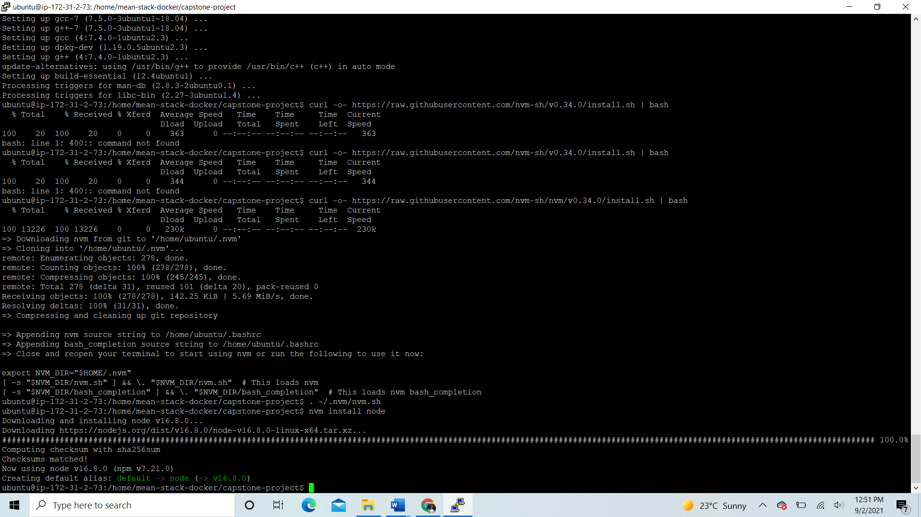

* Created /etc/nginx/sites-available/default file and modified it like so:

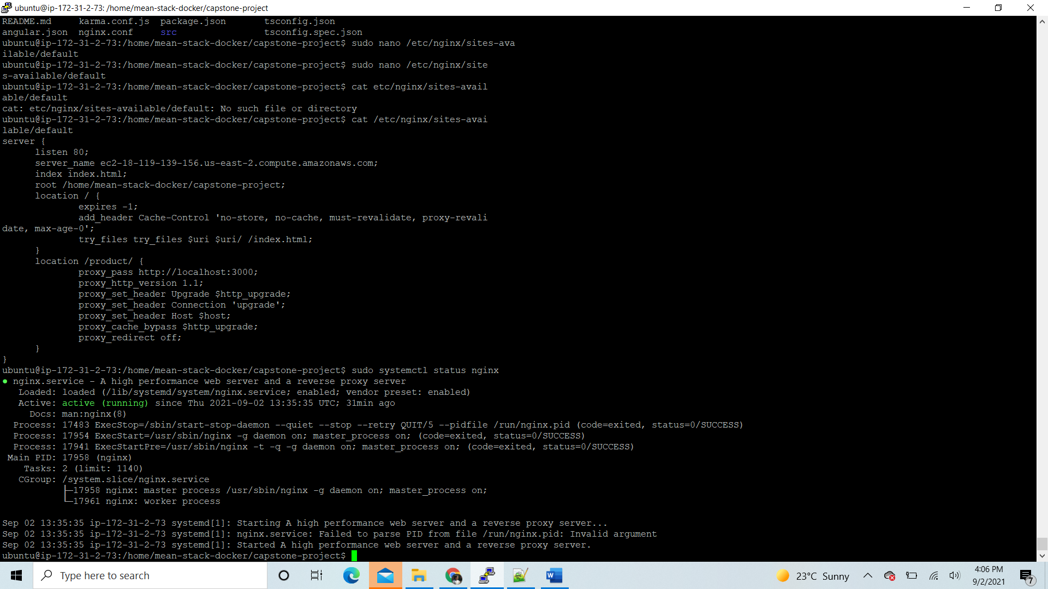

* Checked if nginx is running, and opened browser with the link: http://ec2-18-119-139-156.us-east-2.compute.amazonaws.com:80
* My angular application is running without express server.
* 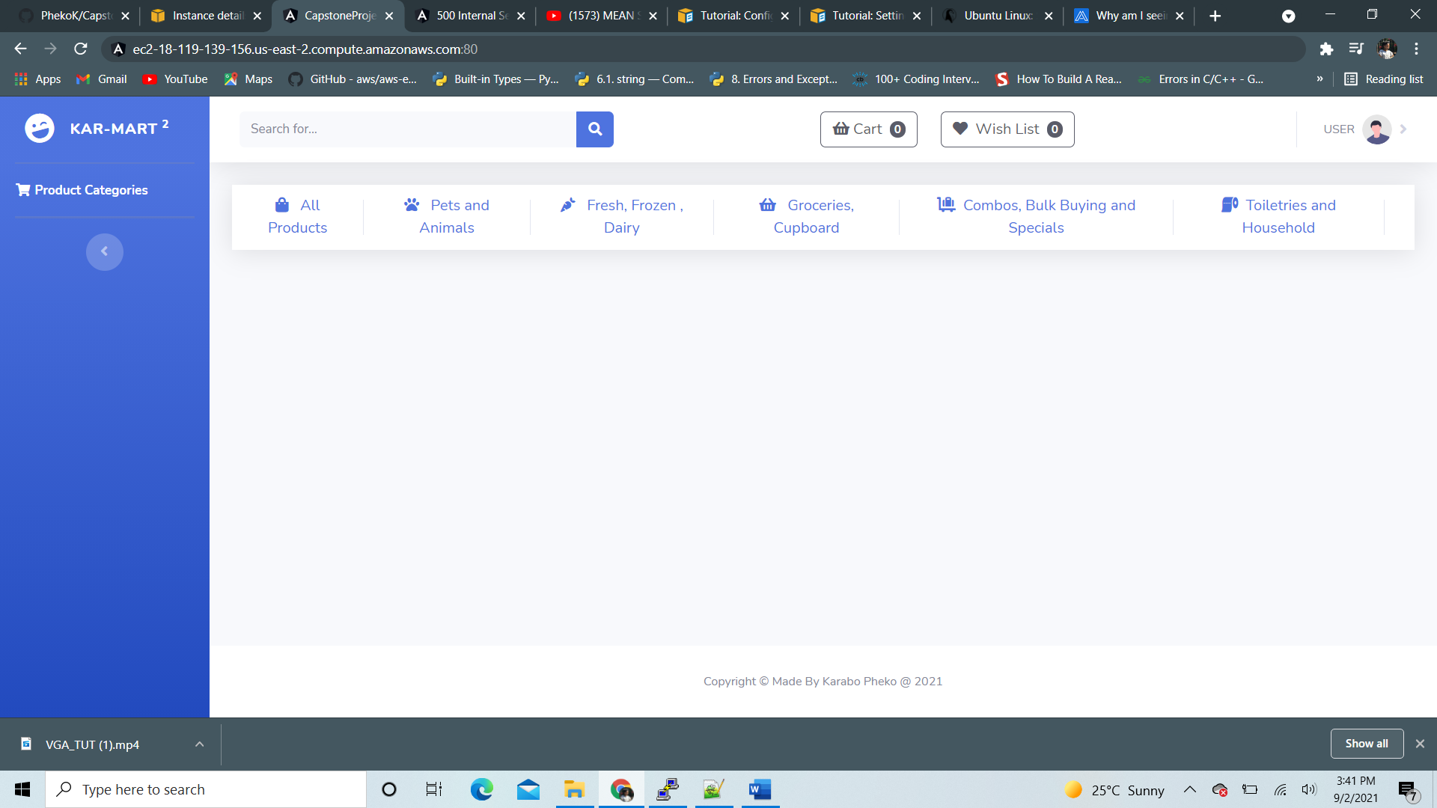
* Installed ‘npm install pm2 -g” to make sure our node script is running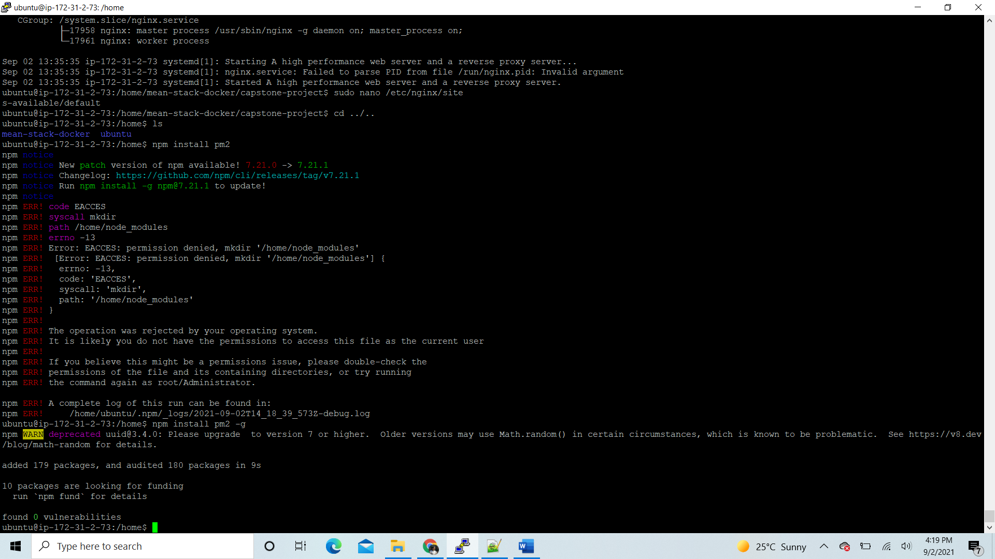
* Run pm2 in production

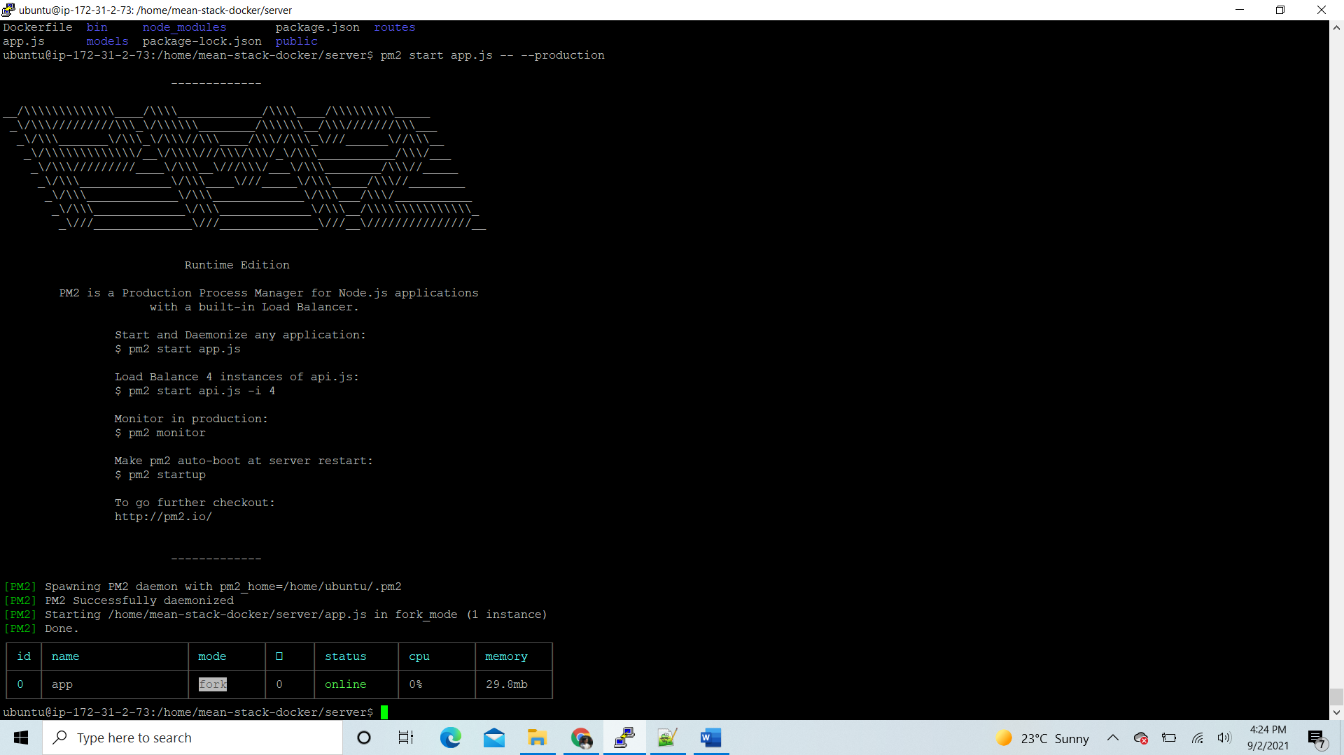

1. Once connected to ec2 instance and everything up and running, you should be able to access the website using the public ipv4 dns provided below:



Public IPv4 DNS:

* Use the link below to log into the application

<http://ec2-18-119-139-156.us-east-2.compute.amazonaws.com:80> , this lands you to the product page

* The website is now running under EC2 instance

